Building Regression Models

Vinay Vaida

2023-09-25

BUILDING REGRESSION MODELS FOR PREDICTION

General principles Our general principles for building regression models for prediction are as follows:

1. Include all input variables that, for substantive reasons, might be expected to be important in predicting the outcome.
2. It is not always necessary to include these inputs as separate predictors—for example, sometimes several inputs can be averaged or summed to create a “total score” that can be used as a single predictor in the model.
3. For inputs that have large effects, consider including their interactions as well.
4. We suggest the following strategy for decisions regarding whether to exclude a variable from a prediction model based on expected sign and statistical signifi- cance (typically measured at the 5% level; that is, a coefficient is “statistically significant” if its estimate is more than 2 standard errors from zero):
   1. If a predictor is not statistically significant and has the expected sign, it is generally fine to keep it in. It may not help predictions dramatically but is also probably not hurting them.
   2. If a predictor is not statistically significant and does not have the expected sign (for example, incumbency having a negative effect on vote share), consider removing it from the model (that is, setting its coefficient to zero).
   3. If a predictor is statistically significant and does not have the expected sign, then think hard if it makes sense. (For example, perhaps this is a country such as India in which incumbents are generally unpopular; see Linden, 2006.) Try to gather data on potential lurking variables and include them in the analysis.
   4. If a predictor is statistically significant and has the expected sign, then by all means keep it in the model.

These strategies do not completely solve our problems but they help keep us from making mistakes such as discarding important information.

## 1. Predicting the yields of mesquite bushes

The outcome variable is the **total weight** (in grams) of photosynthetic material as derived from actual harvesting of the bush. The input variables are:

* diam1: diameter of the canopy (the leafy area of the bush) in meters, measured along the longer axis of the bush
* diam2: canopy diameter measured along the shorter axis
* canopy.height: height of the canopy
* total.height: total height of the bush
* density: plant unit density (# of primary stems per plant unit)
* group: group of measurements (0 for the first group, 1 for the second group)

library(ggplot2)  
library(GGally)

## Registered S3 method overwritten by 'GGally':  
## method from   
## +.gg ggplot

mesquite<-read.csv("C:/Users/vinay/OneDrive/Documents/Applied Stats/assignment 3/mesquite.dat", sep="", stringsAsFactors=TRUE)

Observe variables and relationships with ggpairs, except for index variables.

ggpairs(mesquite[,-(1:2)])

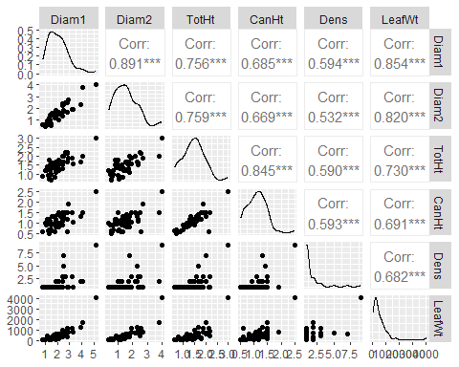

Make a table of the Group variable:

table(mesquite$Group)

##   
## ALS MCD   
## 20 26

Leaf weight is skewed to the right. Taking log may make it more symmetric. We’ll do that later, but for now, let’s look at the distribution of log(LeafWt):

hist(log(mesquite$LeafWt))

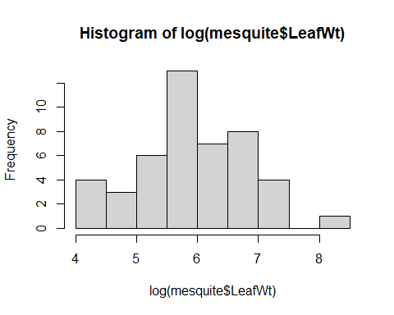

Compare relationships of LeafWt with Diam1

par(mfrow=c(2,2))  
  
plot(LeafWt~Diam1,mesquite)  
plot(log(LeafWt)~Diam1,mesquite)  
plot(log(LeafWt)~log(Diam1),mesquite)

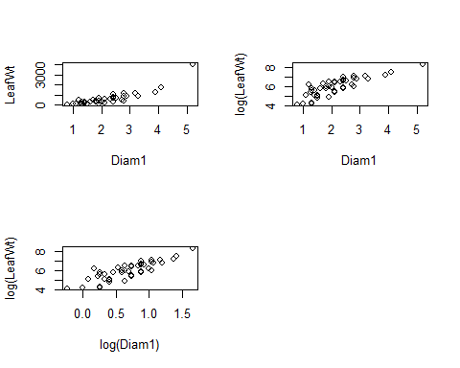

* 1. (5pts) In this situation, taking logs seem to me the relationships more linear. Fit a model where all numeric variables have been transformed with log(). Make a summary of the model and look at the assessment plots.

logLW<-lm(log(LeafWt) ~ log(Diam1) + log(Diam2) + log(TotHt) + log(CanHt) + log(Dens), data=mesquite)  
summary(logLW)

##   
## Call:  
## lm(formula = log(LeafWt) ~ log(Diam1) + log(Diam2) + log(TotHt) +   
## log(CanHt) + log(Dens), data = mesquite)  
##   
## Residuals:  
## Min 1Q Median 3Q Max   
## -0.93661 -0.23791 0.08061 0.29275 0.84700   
##   
## Coefficients:  
## Estimate Std. Error t value Pr(>|t|)   
## (Intercept) 4.971382 0.181144 27.444 < 2e-16 ***  
## log(Diam1) 0.729969 0.331979 2.199 0.03373 *   
## log(Diam2) 0.786969 0.237002 3.321 0.00193 **   
## log(TotHt) 0.702013 0.372764 1.883 0.06695 .   
## log(CanHt) 0.005042 0.327723 0.015 0.98780   
## log(Dens) -0.107387 0.136888 -0.784 0.43738   
## ---  
## Signif. codes: 0 '***' 0.001 '**' 0.01 '*' 0.05 '.' 0.1 ' ' 1  
##   
## Residual standard error: 0.4021 on 40 degrees of freedom  
## Multiple R-squared: 0.8279, Adjusted R-squared: 0.8063   
## F-statistic: 38.47 on 5 and 40 DF, p-value: 2.939e-14

plot(logLW)

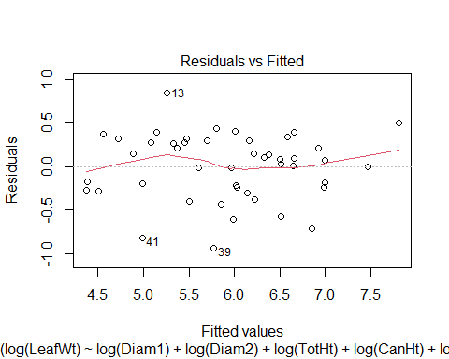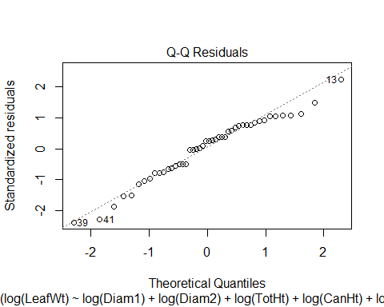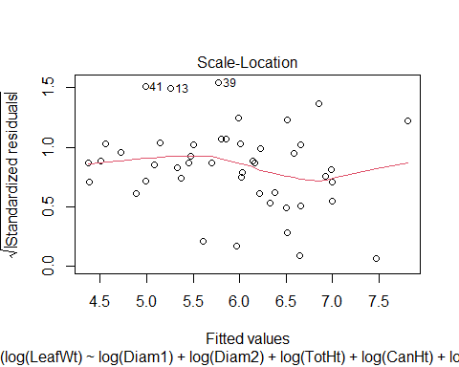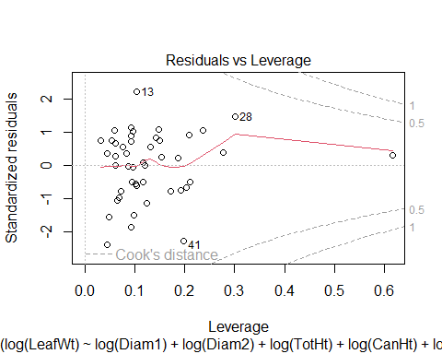

Remove log(CanHt) and log(Dens) and repeat.

logLW2<-lm(log(LeafWt) ~ log(Diam1) + log(Diam2) + log(TotHt), data=mesquite)  
summary(logLW2)

##   
## Call:  
## lm(formula = log(LeafWt) ~ log(Diam1) + log(Diam2) + log(TotHt),   
## data = mesquite)  
##   
## Residuals:  
## Min 1Q Median 3Q Max   
## -0.97651 -0.24317 0.00991 0.31258 0.84934   
##   
## Coefficients:  
## Estimate Std. Error t value Pr(>|t|)   
## (Intercept) 4.9994 0.1523 32.820 < 2e-16 ***  
## log(Diam1) 0.6536 0.3121 2.094 0.04234 *   
## log(Diam2) 0.8014 0.2319 3.457 0.00127 **   
## log(TotHt) 0.6605 0.2518 2.623 0.01210 *   
## ---  
## Signif. codes: 0 '***' 0.001 '**' 0.01 '*' 0.05 '.' 0.1 ' ' 1  
##   
## Residual standard error: 0.3955 on 42 degrees of freedom  
## Multiple R-squared: 0.8251, Adjusted R-squared: 0.8127   
## F-statistic: 66.07 on 3 and 42 DF, p-value: 5.995e-16

plot(logLW2)

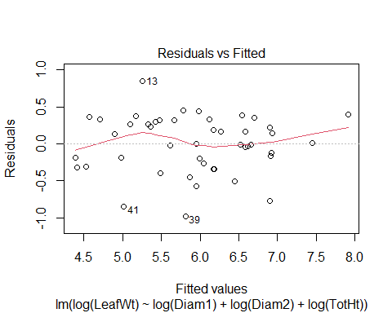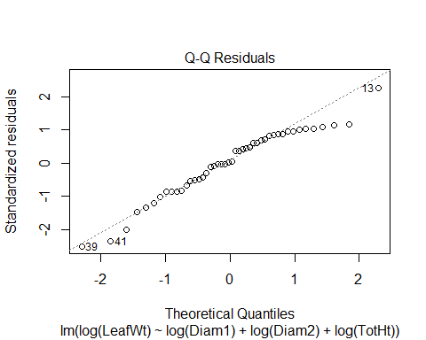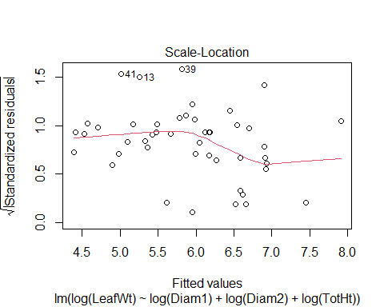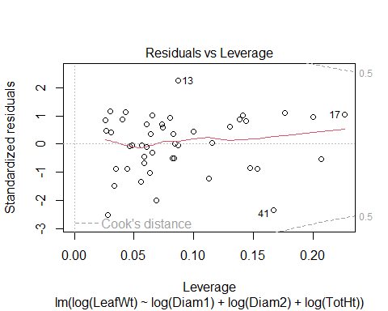

* + 1. Let’s plot by group. The group is being set in the aestetics (aes) of the plot with col=Group.

library(ggplot2)  
  
ggplot(mesquite,aes(x=log(Diam1),y=log(LeafWt),col=Group))+geom_point()+stat_smooth(method="lm")

## `geom_smooth()` using formula = 'y ~ x'

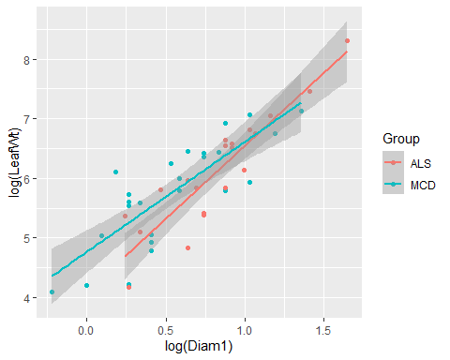

Run a model with interactions between Group and Diam1, and see if there is a significant improvement. Print the summary and look at assessment plots.

logLW3 <- lm(log(LeafWt) ~ log(Diam1)*Group + log(Diam2) + log(TotHt), data=mesquite)  
summary(logLW3)

##   
## Call:  
## lm(formula = log(LeafWt) ~ log(Diam1) * Group + log(Diam2) +   
## log(TotHt), data = mesquite)  
##   
## Residuals:  
## Min 1Q Median 3Q Max   
## -0.67414 -0.11508 0.07737 0.14125 0.74765   
##   
## Coefficients:  
## Estimate Std. Error t value Pr(>|t|)   
## (Intercept) 4.4715 0.1950 22.933 < 2e-16 ***  
## log(Diam1) 0.8309 0.3125 2.658 0.011235 *   
## GroupMCD 0.8175 0.2265 3.609 0.000846 ***  
## log(Diam2) 1.0939 0.2004 5.457 2.73e-06 ***  
## log(TotHt) 0.6490 0.2144 3.027 0.004307 **   
## log(Diam1):GroupMCD -0.4700 0.2790 -1.685 0.099854 .   
## ---  
## Signif. codes: 0 '***' 0.001 '**' 0.01 '*' 0.05 '.' 0.1 ' ' 1  
##   
## Residual standard error: 0.325 on 40 degrees of freedom  
## Multiple R-squared: 0.8875, Adjusted R-squared: 0.8734   
## F-statistic: 63.11 on 5 and 40 DF, p-value: < 2.2e-16

plot(logLW3)

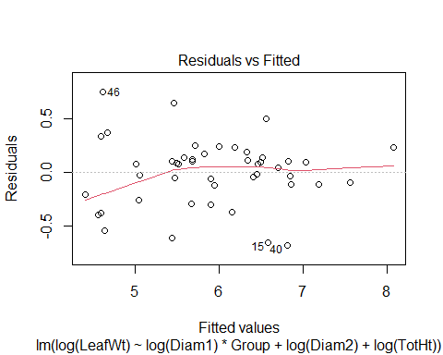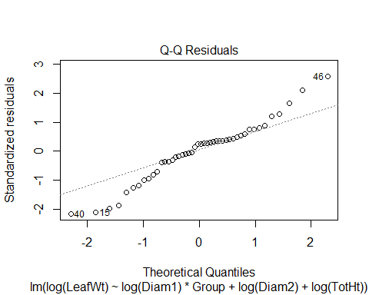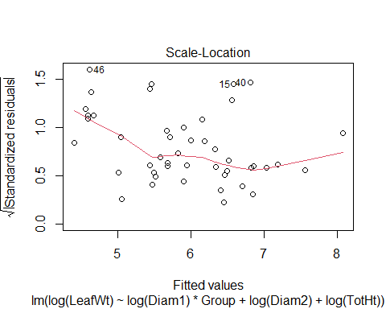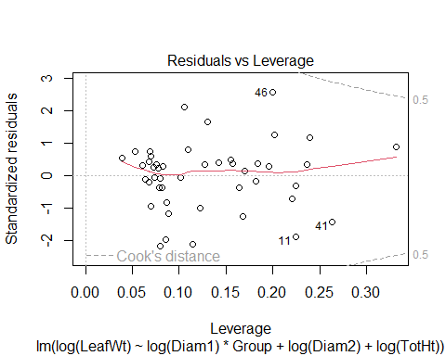

1.c) (5) Using model logLW3, write the equation corresponding to each of the groups ALS and MCD. Interpret the effect of Diam1.

case ALS: logLW3=4.4715+0.8309 log(Diam1)+1.0939 log(Diam2)+0.6490 log(TotHt)

case MCD: logLW3=4.4715+0.8309log(Diam1)+1.0939log(Diam2)+0.6490log(TotHt)+0.8175-0.4700

log(Diam1)=4.4715+0.3609 log(Diam1)+1.0939 log(Diam2)+0.6490 log(TotHt)+0.8175

Effect: Case ALS: a one-unit increase in log(Diam1) is associated with an increase in log(LeafWt) by 0.8309 units, holding other variables constant.

Case MCD: a one-unit increase in log(Diam1) is associated with an increase in log(LeafWt) by 0.3609 units, holding other variables constant.

## 2. Earnings vs Height

The folder **earnings** has data from the Work, Family, and Well-Being Survey (Ross, 1990). Pull out the data on earnings, sex, height, and weight.

library(foreign)  
ht<-read.dta("C:/Users/vinay/OneDrive/Documents/Applied Stats/assignment 3/heights.dta", convert.dates = TRUE, convert.factors = TRUE,missing.type = FALSE,convert.underscore = FALSE, warn.missing.labels = TRUE)  
ht

## earn height1 height2 sex race hisp ed yearbn height  
## 1 NA 5 6 2 1 2 12 53 66  
## 2 NA 5 4 1 2 2 12 50 64  
## 3 50000 6 2 1 1 2 16 45 74  
## 4 60000 5 6 2 1 2 16 32 66  
## 5 30000 5 4 2 1 2 16 61 64  
## 6 NA 5 5 2 1 2 17 33 65  
## 7 50000 5 3 2 3 2 16 99 63  
## 8 NA 5 8 2 2 2 18 36 68  
## 9 51000 5 3 2 1 2 17 51 63  
## 10 9000 5 4 2 1 2 15 64 64  
## 11 29000 5 2 2 1 2 12 41 62  
## 12 32000 6 1 1 1 2 17 44 73  
## 13 2000 6 0 1 1 1 15 69 72  
## 14 NA 6 0 1 1 2 99 37 72  
## 15 27000 6 0 1 1 2 12 64 72  
## 16 6530 5 10 1 1 2 16 25 70  
## 17 0 5 3 2 1 2 14 40 63  
## 18 30000 5 8 1 1 2 11 56 68  
## 19 12000 5 8 1 1 2 12 63 68  
## 20 NA 5 11 1 1 2 18 39 71  
## 21 12000 5 5 2 1 2 12 39 65  
## 22 NA 5 6 2 1 2 11 45 66  
## 23 0 5 0 2 1 2 12 63 60  
## 24 NA 5 5 2 1 2 12 49 65  
## 25 NA 5 9 1 1 2 10 39 69  
## 26 22000 5 6 2 1 2 16 55 66  
## 27 NA 5 5 2 1 2 16 61 65  
## 28 NA 5 11 1 1 2 14 68 71  
## 29 17000 5 8 1 1 2 12 32 68  
## 30 40000 5 8 2 1 2 14 61 68  
## 31 44000 5 10 1 1 2 13 46 70  
## 32 0 5 7 2 1 2 9 69 67  
## 33 7000 5 4 2 2 2 12 35 64  
## 34 53000 6 1 1 2 2 13 55 73  
## 35 NA 5 4 2 2 2 12 67 64  
## 36 5000 5 2 2 1 2 13 39 62  
## 37 NA 5 4 2 1 2 12 99 64  
## 38 14000 5 3 2 1 2 14 69 63  
## 39 NA 5 9 1 1 2 14 54 69  
## 40 5500 5 7 1 1 2 14 68 67  
## 41 40000 5 6 2 1 2 12 49 66  
## 42 34000 6 0 1 1 2 12 45 72  
## 43 NA 5 3 2 2 2 12 67 63  
## 44 NA 5 4 2 1 2 12 33 64  
## 45 10000 5 3 2 2 2 12 55 63  
## 46 0 5 8 1 1 2 11 69 68  
## 47 27000 5 4 2 1 2 16 30 64  
## 48 NA 6 1 1 1 2 14 46 73  
## 49 NA 5 7 2 1 2 12 21 67  
## 50 0 5 0 2 1 2 12 46 60  
## 51 50000 6 0 1 1 2 16 52 72  
## 52 0 5 8 2 1 2 12 35 68  
## 53 41000 6 5 1 1 2 16 57 77  
## 54 0 5 4 2 1 2 10 71 64  
## 55 15000 5 4 2 1 2 14 65 64  
## 56 25000 5 4 2 1 2 12 57 64  
## 57 NA 5 3 2 1 2 16 18 63  
## 58 75000 6 0 1 1 2 17 51 72  
## 59 NA 5 8 1 2 2 16 28 68  
## 60 27000 5 8 1 1 2 17 59 68  
## 61 12000 5 4 2 1 2 12 64 64  
## 62 NA 5 10 1 1 2 12 39 70  
## 63 7500 5 1 2 1 2 14 12 61  
## 64 NA 6 4 1 2 2 11 49 76  
## 65 NA 5 5 2 1 2 12 44 65  
## 66 NA 5 4 1 2 2 12 29 64  
## 67 30000 5 7 2 2 2 14 59 67  
## 68 21000 5 5 2 1 2 12 33 65  
## 69 27000 5 4 2 1 2 14 64 64  
## 70 NA 6 1 1 1 2 16 46 73  
## 71 3000 5 7 2 1 2 15 25 67  
## 72 25000 5 5 2 1 2 12 60 65  
## 73 24000 5 5 2 1 2 12 49 65  
## 74 32000 5 7 2 1 2 18 61 67  
## 75 NA NA 98 2 1 2 4 0 NA  
## 76 NA 5 11 1 2 2 12 99 71  
## 77 10000 5 8 2 1 2 17 60 68  
## 78 0 5 10 2 1 2 12 33 70  
## 79 11000 5 0 2 1 1 12 69 60  
## 80 18700 5 5 2 1 2 13 58 65  
## 81 20000 5 2 2 1 2 12 61 62  
## 82 3500 6 0 1 1 2 10 72 72  
## 83 NA 5 6 2 1 2 14 44 66  
## 84 13000 5 7 1 2 2 8 34 67  
## 85 NA 5 9 1 1 2 12 45 69  
## 86 25000 5 10 1 1 2 12 25 70  
## 87 21000 5 10 1 1 2 17 49 70  
## 88 34000 5 8 2 1 2 17 41 68  
## 89 NA 5 6 2 2 2 12 67 66  
## 90 NA 5 1 2 2 2 12 60 61  
## 91 6000 5 0 2 1 2 12 25 60  
## 92 17000 5 11 1 1 2 12 62 71  
## 93 NA 5 10 2 1 2 12 34 70  
## 94 35000 5 11 1 1 2 12 58 71  
## 95 4000 6 1 1 1 2 13 72 73  
## 96 NA 5 4 2 1 2 16 68 64  
## 97 14000 5 8 2 1 2 14 35 68  
## 98 10000 5 6 2 1 2 12 33 66  
## 99 NA 5 9 1 4 2 13 1 69  
## 100 25000 5 9 1 1 2 16 61 69  
## 101 0 5 3 2 1 2 8 27 63  
## 102 NA 5 8 2 1 1 12 61 68  
## 103 NA 5 10 1 1 2 18 30 70  
## 104 16000 5 3 2 1 2 14 63 63  
## 105 0 5 6 2 2 2 13 60 66  
## 106 NA 5 6 2 1 2 12 57 66  
## 107 0 5 4 2 1 2 12 64 64  
## 108 16000 5 2 1 1 1 14 62 62  
## 109 NA 5 6 2 1 2 18 23 66  
## 110 16500 5 4 2 1 2 14 47 64  
## 111 NA 5 8 1 1 2 12 17 68  
## 112 4000 5 4 2 1 2 9 22 64  
## 113 3840 5 7 2 1 2 9 38 67  
## 114 NA 5 0 2 1 2 6 12 60  
## 115 22000 5 11 1 1 2 12 51 71  
## 116 200 5 0 2 1 2 16 37 60  
## 117 26000 5 6 2 1 2 16 63 66  
## 118 2500 5 6 2 1 2 15 69 66  
## 119 17000 5 5 2 1 2 14 51 65  
## 120 NA 5 3 2 1 2 16 55 63  
## 121 8000 5 10 2 1 2 13 68 70  
## 122 NA 5 8 1 1 2 12 59 68  
## 123 0 5 5 2 1 2 13 27 65  
## 124 12000 5 6 2 1 2 13 22 66  
## 125 10000 5 2 2 1 2 12 43 62  
## 126 NA 5 0 2 1 2 8 13 60  
## 127 NA 6 4 1 1 2 16 39 76  
## 128 10000 5 6 2 1 2 15 23 66  
## 129 0 5 4 2 1 2 14 52 64  
## 130 15000 6 0 1 1 2 12 51 72  
## 131 NA 5 6 2 1 2 12 59 66  
## 132 NA 5 2 2 1 2 8 8 62  
## 133 NA 5 6 2 3 2 12 47 66  
## 134 NA 5 9 1 2 2 11 17 69  
## 135 NA 5 8 2 1 2 15 42 68  
## 136 2400 5 7 2 1 1 8 51 67  
## 137 30000 5 8 1 1 1 12 58 68  
## 138 30000 5 10 1 1 2 12 57 70  
## 139 10000 5 2 2 1 2 12 52 62  
## 140 NA 5 10 1 1 2 18 47 70  
## 141 5000 5 3 2 1 2 13 64 63  
## 142 12000 5 6 2 1 2 13 27 66  
## 143 20000 5 10 2 1 2 10 29 70  
## 144 20000 5 8 2 1 2 12 54 68  
## 145 20000 5 10 1 1 2 14 67 70  
## 146 NA 5 5 2 1 2 18 33 65  
## 147 NA 5 8 2 1 2 8 8 68  
## 148 0 5 6 2 1 2 12 31 66  
## 149 NA 5 11 1 1 2 18 14 71  
## 150 1200 5 6 2 1 2 12 70 66  
## 151 NA 5 2 2 1 2 12 21 62  
## 152 700 5 8 2 1 2 16 58 68  
## 153 20000 5 10 1 1 2 16 63 70  
## 154 10000 5 1 2 1 1 12 68 61  
## 155 30000 5 3 2 1 2 12 17 63  
## 156 NA 6 0 1 1 1 8 27 72  
## 157 40000 5 4 2 1 2 14 34 64  
## 158 25000 5 7 1 1 2 12 1 67  
## 159 NA 5 6 2 1 2 18 25 66  
## 160 NA 5 8 2 1 2 14 48 68  
## 161 10000 5 1 2 1 2 17 11 61  
## 162 60000 5 9 2 1 2 18 27 69  
## 163 NA 5 2 2 1 2 12 34 62  
## 164 0 5 4 2 1 2 12 69 64  
## 165 18000 5 8 2 1 2 12 24 68  
## 166 NA 5 0 2 1 2 12 16 60  
## 167 NA 5 11 1 1 2 18 48 71  
## 168 16040 5 4 2 1 2 12 57 64  
## 169 15000 5 7 2 2 2 14 60 67  
## 170 10000 5 9 1 1 2 17 67 69  
## 171 33000 5 7 2 1 2 13 47 67  
## 172 18000 5 8 2 1 2 12 60 68  
## 173 15000 5 3 2 1 2 12 53 63  
## 174 21000 5 11 1 1 2 12 68 71  
## 175 21000 5 4 2 2 2 17 47 64  
## 176 37000 5 8 1 1 2 11 53 68  
## 177 38000 5 8 2 1 2 17 46 68  
## 178 17000 5 6 2 1 1 14 47 66  
## 179 0 5 6 2 1 2 12 61 66  
## 180 0 5 6 2 3 2 16 58 66  
## 181 NA 5 0 2 1 2 16 99 60  
## 182 32000 6 5 1 1 2 16 60 77  
## 183 NA NA NA 1 1 2 12 32 NA  
## 184 27500 5 7 2 1 2 12 32 67  
## 185 NA 5 6 1 1 2 12 14 66  
## 186 16500 5 2 2 1 2 12 46 62  
## 187 NA 5 3 2 1 2 13 99 63  
## 188 0 5 4 2 1 2 17 60 64  
## 189 0 6 0 2 1 2 12 39 72  
## 190 25000 5 7 2 1 2 18 55 67  
## 191 27000 5 1 2 1 2 18 47 61  
## 192 5000 5 4 2 1 2 12 62 64  
## 193 NA 5 10 1 4 2 14 54 70  
## 194 70000 5 2 2 1 2 16 52 62  
## 195 5000 5 3 2 1 2 12 50 63  
## 196 5000 5 8 1 1 2 16 66 68  
## 197 NA 5 9 1 3 2 18 60 69  
## 198 NA 5 4 2 2 2 12 31 64  
## 199 20000 5 4 2 1 2 15 64 64  
## 200 4000 6 0 1 1 2 15 69 72  
## 201 NA 6 0 1 1 2 12 51 72  
## 202 60000 5 4 2 1 2 16 55 64  
## 203 5000 5 1 2 1 2 13 59 61  
## 204 30000 6 2 1 1 2 12 52 74  
## 205 70000 5 10 1 1 2 14 55 70  
## 206 NA 5 4 2 1 2 16 30 64  
## 207 50000 5 11 1 1 2 16 49 71  
## 208 44000 5 3 2 1 2 12 51 63  
## 209 NA NA NA 2 1 2 18 99 NA  
## 210 NA 6 1 1 1 2 18 50 73  
## 211 NA 5 7 1 1 2 17 60 67  
## 212 30000 5 4 2 1 2 14 47 64  
## 213 NA 6 1 1 2 2 14 66 73  
## 214 NA 5 4 2 1 2 16 62 64  
## 215 NA 5 3 2 1 2 15 59 63  
## 216 0 5 2 2 1 2 16 58 62  
## 217 10000 5 2 2 1 2 16 50 62  
## 218 23000 5 10 2 1 2 17 48 70  
## 219 0 5 2 2 1 2 12 51 62  
## 220 45000 5 11 1 1 2 17 28 71  
## 221 15000 5 11 1 1 2 14 59 71  
## 222 NA 5 11 1 1 2 17 57 71  
## 223 4000 5 10 2 1 2 14 19 70  
## 224 17000 5 7 1 1 2 14 59 67  
## 225 30000 5 4 2 1 2 12 58 64  
## 226 27500 5 7 2 1 2 12 60 67  
## 227 5688 5 2 2 1 2 8 21 62  
## 228 18000 5 2 2 1 1 13 34 62  
## 229 NA 5 7 1 1 2 14 54 67  
## 230 NA 5 6 2 1 2 17 58 66  
## 231 NA 5 4 2 1 2 12 27 64  
## 232 43000 5 8 1 2 2 13 46 68  
## 233 32000 5 2 2 2 2 14 46 62  
## 234 NA 5 2 2 2 2 12 70 62  
## 235 0 5 6 2 2 2 5 39 66  
## 236 10000 5 8 2 2 2 18 34 68  
## 237 NA 5 5 2 1 1 12 52 65  
## 238 NA 6 2 1 1 2 12 70 74  
## 239 NA NA NA 2 9 9 16 99 NA  
## 240 60000 6 2 1 1 2 13 45 74  
## 241 NA 5 8 1 1 2 18 24 68  
## 242 NA 5 10 1 1 2 16 60 70  
## 243 NA 5 11 1 1 2 15 67 71  
## 244 21000 5 8 2 4 2 12 40 68  
## 245 2400 5 2 2 1 2 16 68 62  
## 246 NA 5 8 2 1 2 10 40 68  
## 247 NA 5 2 2 2 2 15 48 62  
## 248 1000 5 6 2 1 2 15 62 66  
## 249 27000 5 8 1 1 2 12 63 68  
## 250 6600 5 0 2 1 1 14 62 60  
## 251 NA 5 4 2 2 2 11 39 64  
## 252 16000 5 8 1 1 2 8 47 68  
## 253 90000 6 0 1 1 2 12 64 72  
## 254 8000 5 6 2 1 2 12 48 66  
## 255 20000 5 8 1 1 2 10 58 68  
## 256 15000 5 8 2 1 2 12 72 68  
## 257 12000 5 9 2 1 2 12 30 69  
## 258 NA 5 3 2 1 2 9 23 63  
## 259 24000 5 4 2 1 2 16 44 64  
## 260 20000 5 5 2 1 2 14 51 65  
## 261 NA 4 11 2 1 2 8 8 59  
## 262 19000 5 1 2 1 2 12 44 61  
## 263 NA 5 11 1 1 2 8 37 71  
## 264 10000 6 0 1 1 2 12 41 72  
## 265 40000 5 6 2 1 2 16 56 66  
## 266 NA 5 9 1 1 2 18 46 69  
## 267 NA 5 9 1 2 2 8 55 69  
## 268 NA 5 3 2 2 2 13 52 63  
## 269 NA 5 4 2 1 1 12 54 64  
## 270 0 5 2 2 1 2 10 33 62  
## 271 0 5 0 2 1 1 10 42 60  
## 272 NA 5 2 2 1 2 8 2 62  
## 273 25000 5 8 1 1 2 14 26 68  
## 274 25000 5 10 1 1 2 12 66 70  
## 275 25000 5 11 1 1 2 14 58 71  
## 276 19000 5 11 1 1 2 16 29 71  
## 277 44000 5 8 1 1 2 16 42 68  
## 278 0 5 6 2 1 2 12 71 66  
## 279 0 5 3 2 1 2 18 35 63  
## 280 15000 5 0 2 1 2 14 41 60  
## 281 17000 5 3 2 1 2 12 54 63  
## 282 24000 5 8 1 1 2 12 34 68  
## 283 NA 5 10 1 1 2 16 52 70  
## 284 23000 5 4 2 1 2 12 53 64  
## 285 13000 5 10 1 1 2 12 16 70  
## 286 NA 5 6 2 2 2 98 18 66  
## 287 NA 5 6 2 1 2 12 41 66  
## 288 65000 5 8 1 1 2 16 44 68  
## 289 7000 5 1 2 1 2 12 27 61  
## 290 NA 5 7 2 1 2 16 57 67  
## 291 40000 5 8 1 1 2 18 27 68  
## 292 15000 5 6 2 1 2 17 47 66  
## 293 20000 5 10 1 1 2 16 65 70  
## 294 NA 5 8 1 1 2 6 13 68  
## 295 NA 5 6 2 1 2 14 16 66  
## 296 20000 5 11 1 1 2 12 40 71  
## 297 NA 5 3 1 1 2 9 23 63  
## 298 20000 5 5 2 1 2 12 48 65  
## 299 25000 5 6 2 1 2 12 41 66  
## 300 NA 5 4 2 1 2 14 70 64  
## 301 49000 5 10 1 1 2 13 53 70  
## 302 NA 5 10 1 1 2 8 66 70  
## 303 0 5 4 2 1 2 12 54 64  
## 304 NA 5 4 2 1 2 16 61 64  
## 305 0 5 3 2 1 2 16 55 63  
## 306 25000 5 2 2 1 2 12 25 62  
## 307 NA 5 5 2 1 2 12 23 65  
## 308 NA 5 6 2 1 2 12 28 66  
## 309 NA 5 5 2 1 2 14 27 65  
## 310 NA 5 0 2 1 2 16 18 60  
## 311 11000 5 6 2 1 2 14 33 66  
## 312 16000 5 1 2 1 2 15 52 61  
## 313 35000 6 0 1 1 2 14 47 72  
## 314 125000 6 2 1 1 2 18 45 74  
## 315 23000 5 7 2 1 2 12 43 67  
## 316 17000 5 6 2 1 2 16 62 66  
## 317 0 5 2 2 1 2 13 59 62  
## 318 27000 5 2 2 1 2 12 49 62  
## 319 70000 6 0 1 1 2 14 58 72  
## 320 35000 5 5 2 1 2 15 43 65  
## 321 10000 5 0 2 1 2 12 28 60  
## 322 NA 5 4 2 1 2 13 60 64  
## 323 35000 5 2 2 1 2 15 51 62  
## 324 15000 5 6 2 1 2 12 52 66  
## 325 12000 5 4 2 1 2 12 51 64  
## 326 8000 5 11 1 1 2 12 22 71  
## 327 8000 5 5 2 1 2 12 40 65  
## 328 35000 6 1 1 1 2 18 40 73  
## 329 45000 5 9 1 1 2 11 39 69  
## 330 NA 5 5 2 1 2 12 53 65  
## 331 0 5 4 2 1 2 12 32 64  
## 332 NA 5 4 2 1 2 12 63 64  
## 333 NA 5 8 2 1 2 12 32 68  
## 334 15000 5 4 2 1 2 14 68 64  
## 335 15000 5 1 2 1 2 12 13 61  
## 336 NA 6 1 1 1 2 15 64 73  
## 337 24000 5 7 2 1 2 18 39 67  
## 338 25000 5 2 2 1 2 13 58 62  
## 339 NA 6 1 1 1 2 12 56 73  
## 340 25000 5 3 2 2 2 14 36 63  
## 341 20000 5 7 1 3 2 10 62 67  
## 342 24000 5 8 2 1 2 12 66 68  
## 343 44000 6 0 1 1 2 16 44 72  
## 344 69000 5 10 1 1 2 12 52 70  
## 345 62000 5 10 1 1 2 18 46 70  
## 346 NA 5 0 2 2 2 15 25 60  
## 347 32000 5 7 1 2 2 14 58 67  
## 348 20000 5 3 2 2 2 12 57 63  
## 349 32000 5 6 2 3 2 18 55 66  
## 350 25000 5 6 2 1 2 17 40 66  
## 351 170000 5 11 1 1 2 18 45 71  
## 352 NA 5 9 1 2 2 14 47 69  
## 353 0 5 6 2 2 2 11 61 66  
## 354 35000 5 7 1 1 2 16 57 67  
## 355 40000 6 4 1 2 2 16 52 76  
## 356 33000 5 9 1 1 2 14 60 69  
## 357 18000 5 5 2 1 2 12 68 65  
## 358 NA 5 8 1 1 2 12 38 68  
## 359 NA 5 1 2 1 2 9 18 61  
## 360 30000 5 2 2 1 2 13 47 62  
## 361 26000 5 2 2 1 2 12 59 62  
## 362 5000 5 2 2 1 2 12 69 62  
## 363 NA 5 9 2 1 2 12 72 69  
## 364 20000 5 2 2 1 2 16 17 62  
## 365 NA 6 0 1 1 2 11 60 72  
## 366 NA 5 7 2 1 2 12 49 67  
## 367 17000 5 1 2 1 2 12 60 61  
## 368 32000 5 5 2 1 2 14 62 65  
## 369 15000 6 0 1 1 2 14 68 72  
## 370 0 5 6 2 1 2 17 49 66  
## 371 50000 6 0 1 1 2 14 35 72  
## 372 8000 5 4 2 1 2 12 51 64  
## 373 40000 5 11 1 1 2 14 39 71  
## 374 40000 6 0 1 1 2 15 49 72  
## 375 32750 5 6 1 1 2 12 56 66  
## 376 NA 5 8 1 1 2 12 70 68  
## 377 20000 5 5 2 1 2 14 21 65  
## 378 36000 5 5 2 2 2 15 51 65  
## 379 6000 5 2 2 1 2 12 26 62  
## 380 12000 5 6 2 2 1 14 56 66  
## 381 NA 5 7 1 1 2 18 52 67  
## 382 60000 5 7 1 1 2 14 27 67  
## 383 40000 5 4 2 1 2 13 46 64  
## 384 NA 6 2 1 1 1 13 71 74  
## 385 43000 5 3 2 1 2 12 52 63  
## 386 45000 5 7 2 1 2 16 56 67  
## 387 6000 5 8 2 1 2 18 51 68  
## 388 8000 5 4 2 4 2 10 8 64  
## 389 20000 5 4 2 2 2 13 51 64  
## 390 NA 5 6 2 1 2 7 8 66  
## 391 17000 5 6 1 2 2 12 67 66  
## 392 2000 5 5 2 1 2 12 58 65  
## 393 65000 5 5 1 1 2 12 62 65  
## 394 50000 6 0 1 1 2 12 49 72  
## 395 0 5 8 2 1 2 11 36 68  
## 396 0 5 3 2 1 2 11 61 63  
## 397 NA 5 10 1 1 2 13 69 70  
## 398 11000 5 8 2 1 2 12 52 68  
## 399 35000 6 2 1 1 2 18 60 74  
## 400 27000 5 3 1 1 2 12 57 63  
## 401 3500 5 4 2 1 2 12 29 64  
## 402 NA 5 5 2 1 2 7 13 65  
## 403 42000 5 8 1 1 2 12 53 68  
## 404 NA 5 1 2 1 2 12 29 61  
## 405 20000 5 7 2 1 2 18 61 67  
## 406 15000 5 7 2 1 2 12 61 67  
## 407 10000 6 1 1 1 2 12 69 73  
## 408 0 5 2 2 1 2 12 42 62  
## 409 6000 5 10 1 1 2 8 12 70  
## 410 NA 5 9 2 1 2 14 29 69  
## 411 NA 5 11 1 1 2 12 10 71  
## 412 17000 5 5 2 1 1 16 67 65  
## 413 NA 5 2 2 1 1 8 67 62  
## 414 35000 5 9 1 1 1 16 25 69  
## 415 28000 6 5 1 1 2 14 62 77  
## 416 15000 5 8 2 1 2 12 57 68  
## 417 20000 5 2 2 1 2 17 66 62  
## 418 20000 5 4 2 1 2 12 61 64  
## 419 NA 5 10 1 1 1 18 60 70  
## 420 10500 5 7 1 3 1 12 48 67  
## 421 13000 5 10 1 1 2 16 68 70  
## 422 10000 5 2 2 1 2 12 38 62  
## 423 3000 5 3 2 1 2 12 53 63  
## 424 24000 5 2 2 1 2 14 61 62  
## 425 0 5 3 2 1 2 17 49 63  
## 426 17000 5 9 2 1 2 13 55 69  
## 427 11000 5 4 2 1 2 12 42 64  
## 428 0 5 4 2 1 2 14 53 64  
## 429 32000 5 9 2 1 2 14 50 69  
## 430 17000 4 11 2 1 2 15 64 59  
## 431 NA 5 1 2 1 2 16 43 61  
## 432 NA 5 0 2 1 2 12 15 60  
## 433 NA 6 0 1 1 2 12 41 72  
## 434 NA 5 8 1 1 2 14 35 68  
## 435 3000 5 6 2 4 2 12 55 66  
## 436 NA 5 3 2 1 2 8 30 63  
## 437 0 5 5 2 1 2 12 49 65  
## 438 NA 5 10 1 1 2 18 32 70  
## 439 NA 6 0 1 1 2 14 42 72  
## 440 2100 5 2 2 2 2 12 69 62  
## 441 NA 5 10 1 2 2 10 8 70  
## 442 NA 5 0 2 1 2 13 14 60  
## 443 NA 5 6 2 2 2 12 61 66  
## 444 NA 5 4 1 1 1 12 56 64  
## 445 NA 5 11 1 1 2 16 67 71  
## 446 NA 6 1 1 2 2 12 63 73  
## 447 3192 6 3 1 2 2 11 56 75  
## 448 NA 5 2 2 3 2 12 65 62  
## 449 17000 5 3 2 1 2 17 64 63  
## 450 30000 5 5 2 1 2 13 62 65  
## 451 15000 5 10 1 1 2 12 58 70  
## 452 NA 5 4 2 1 2 16 64 64  
## 453 NA 5 8 1 3 2 18 56 68  
## 454 24000 5 8 2 1 2 16 48 68  
## 455 10000 5 5 2 1 2 14 23 65  
## 456 50000 5 9 1 1 2 8 37 69  
## 457 NA 5 4 2 1 2 11 13 64  
## 458 50000 6 0 1 1 2 16 37 72  
## 459 NA 5 9 1 1 2 12 52 69  
## 460 20000 5 4 2 1 2 17 41 64  
## 461 30000 5 3 2 1 1 18 36 63  
## 462 NA 5 8 2 1 2 18 54 68  
## 463 NA 5 8 2 1 2 18 49 68  
## 464 0 5 4 2 1 2 12 27 64  
## 465 0 5 6 2 1 2 10 42 66  
## 466 NA 5 10 1 1 2 12 53 70  
## 467 0 5 3 2 1 2 5 32 63  
## 468 22000 6 1 2 1 2 14 45 73  
## 469 NA 5 9 1 1 2 12 70 69  
## 470 27000 6 3 1 1 2 12 66 75  
## 471 4000 5 5 2 1 2 12 52 65  
## 472 NA 5 4 2 1 2 16 49 64  
## 473 17500 5 6 2 1 2 17 64 66  
## 474 16500 5 6 2 1 2 14 62 66  
## 475 NA 5 4 2 1 2 18 53 64  
## 476 28000 5 4 2 1 2 16 51 64  
## 477 52000 5 6 2 1 2 18 40 66  
## 478 15000 5 4 2 1 2 16 61 64  
## 479 19000 5 3 2 1 2 13 58 63  
## 480 0 5 3 2 1 2 13 46 63  
## 481 NA 5 7 2 2 2 12 71 67  
## 482 NA 5 9 2 1 2 12 56 69  
## 483 27000 6 1 1 1 2 12 67 73  
## 484 15000 6 0 1 1 2 8 32 72  
## 485 NA 5 3 2 1 2 12 48 63  
## 486 0 5 6 2 1 2 12 66 66  
## 487 15000 6 0 1 1 2 14 57 72  
## 488 14500 5 4 2 1 2 12 35 64  
## 489 NA 6 0 1 1 2 16 50 72  
## 490 NA 5 3 2 1 2 12 35 63  
## 491 24000 5 4 2 1 2 13 60 64  
## 492 NA 5 5 2 1 2 14 60 65  
## 493 NA 5 2 2 1 2 13 50 62  
## 494 NA 5 1 2 1 2 12 72 61  
## 495 18000 5 8 1 1 2 15 54 68  
## 496 4000 5 2 2 1 2 12 22 62  
## 497 NA 5 4 2 1 2 12 5 64  
## 498 4000 5 9 2 1 2 13 33 69  
## 499 NA 5 6 2 1 2 15 37 66  
## 500 700 5 0 2 1 2 12 54 60  
## 501 NA 5 4 2 1 2 15 57 64  
## 502 24000 5 5 2 1 2 12 99 65  
## 503 NA 5 0 2 1 2 12 30 60  
## 504 27000 6 4 1 1 2 12 51 76  
## 505 12000 6 0 2 1 2 12 55 72  
## 506 22000 5 2 2 1 2 18 43 62  
## 507 30000 5 2 2 1 2 13 54 62  
## 508 NA 5 10 1 1 2 16 55 70  
## 509 35000 5 11 1 1 2 12 29 71  
## 510 20000 6 2 1 1 2 12 48 74  
## 511 32000 5 5 2 1 2 16 58 65  
## 512 6000 5 3 2 4 2 12 59 63  
## 513 12000 5 7 2 1 2 12 51 67  
## 514 0 5 5 2 1 2 16 46 65  
## 515 10000 5 3 2 1 2 12 59 63  
## 516 1000 5 5 2 1 2 12 72 65  
## 517 12000 5 4 2 1 2 15 19 64  
## 518 16000 5 5 2 1 2 12 54 65  
## 519 NA 5 3 2 1 2 13 63 63  
## 520 0 5 8 2 1 2 16 49 68  
## 521 25000 5 3 2 1 2 16 57 63  
## 522 25000 5 10 2 1 2 12 63 70  
## 523 32000 5 8 1 1 2 12 60 68  
## 524 NA 5 6 1 1 2 11 11 66  
## 525 35000 5 7 1 1 2 14 47 67  
## 526 NA 5 8 1 1 2 12 66 68  
## 527 NA 5 6 2 1 2 12 67 66  
## 528 6000 5 5 2 1 2 12 62 65  
## 529 80000 5 9 1 1 2 14 46 69  
## 530 20000 5 8 2 1 2 14 65 68  
## 531 1000 5 6 2 1 2 17 52 66  
## 532 28000 5 11 1 1 1 13 52 71  
## 533 26000 5 4 1 1 1 16 67 64  
## 534 27000 6 2 1 1 2 12 66 74  
## 535 18000 5 2 2 1 2 13 49 62  
## 536 2000 5 5 2 1 2 12 31 65  
## 537 20000 5 9 1 1 2 12 24 69  
## 538 NA NA 98 2 2 2 12 29 NA  
## 539 NA 6 0 1 2 2 12 71 72  
## 540 NA 5 5 1 1 2 11 59 65  
## 541 6000 5 6 2 1 2 16 42 66  
## 542 NA 5 10 1 1 2 11 58 70  
## 543 NA 5 1 2 1 2 12 16 61  
## 544 0 5 0 2 1 2 10 22 60  
## 545 NA 5 10 1 1 2 12 71 70  
## 546 NA 6 1 2 1 2 11 69 73  
## 547 NA 5 6 2 1 2 12 16 66  
## 548 NA 4 9 2 1 1 12 54 57  
## 549 25000 5 7 1 1 2 11 27 67  
## 550 12000 6 1 1 1 2 12 61 73  
## 551 0 5 5 2 1 2 18 64 65  
## 552 NA 5 2 2 1 2 12 45 62  
## 553 12000 6 4 1 1 2 12 33 76  
## 554 30000 5 10 1 1 2 14 14 70  
## 555 0 5 4 2 1 2 12 60 64  
## 556 4000 5 3 2 2 2 15 68 63  
## 557 NA 5 7 2 2 2 11 72 67  
## 558 26000 5 3 2 2 2 13 53 63  
## 559 NA 5 9 2 1 2 9 37 69  
## 560 NA 5 7 2 1 2 9 67 67  
## 561 NA 5 6 2 2 2 12 60 66  
## 562 NA 5 1 2 2 2 12 65 61  
## 563 23000 5 10 1 2 2 12 55 70  
## 564 21000 5 11 1 1 2 12 57 71  
## 565 25000 5 5 2 1 2 12 28 65  
## 566 18000 5 10 1 1 2 16 15 70  
## 567 4000 5 3 2 1 2 13 46 63  
## 568 23900 5 4 2 1 2 12 68 64  
## 569 NA 5 8 1 1 2 12 22 68  
## 570 35000 5 4 2 1 2 18 50 64  
## 571 26000 5 7 1 1 2 14 60 67  
## 572 25000 5 6 1 1 2 16 54 66  
## 573 23500 5 8 2 1 2 13 63 68  
## 574 12000 5 5 2 1 2 12 68 65  
## 575 15000 5 7 2 1 2 12 70 67  
## 576 NA 5 1 2 1 2 8 23 61  
## 577 3000 6 1 1 1 2 17 67 73  
## 578 NA 5 3 2 1 2 12 22 63  
## 579 NA 5 6 2 1 2 12 53 66  
## 580 6000 5 4 2 1 2 12 23 64  
## 581 14000 5 11 1 1 2 12 21 71  
## 582 15000 5 3 2 1 2 16 59 63  
## 583 175000 5 11 1 1 2 16 42 71  
## 584 0 5 3 2 1 2 12 39 63  
## 585 NA 5 4 2 1 2 16 20 64  
## 586 1000 6 1 1 1 2 18 65 73  
## 587 10000 5 5 2 1 2 14 27 65  
## 588 45000 5 6 1 1 2 13 8 66  
## 589 15000 5 6 2 1 2 12 9 66  
## 590 NA 5 0 2 1 2 15 11 60  
## 591 NA 5 8 2 1 2 18 38 68  
## 592 20000 4 11 2 1 2 13 49 59  
## 593 NA 5 10 1 1 2 12 48 70  
## 594 NA 5 2 2 1 2 15 99 62  
## 595 35000 5 10 1 1 2 16 60 70  
## 596 40000 6 0 1 1 2 16 62 72  
## 597 35000 5 4 2 1 2 12 18 64  
## 598 NA 6 0 1 1 2 12 57 72  
## 599 50000 5 6 2 1 2 16 36 66  
## 600 100000 5 10 1 1 2 18 33 70  
## 601 NA 5 3 2 1 2 12 60 63  
## 602 35000 5 9 1 1 2 13 62 69  
## 603 0 5 6 2 1 2 12 39 66  
## 604 24000 5 8 2 1 2 12 55 68  
## 605 0 5 4 2 1 2 12 60 64  
## 606 NA 5 7 2 1 2 14 55 67  
## 607 NA 5 0 2 1 2 16 18 60  
## 608 0 5 3 2 1 2 12 30 63  
## 609 35000 6 2 1 1 2 17 47 74  
## 610 NA 5 1 2 1 2 18 23 61  
## 611 38000 6 1 1 1 2 16 16 73  
## 612 NA 5 10 1 1 2 13 61 70  
## 613 NA 6 1 1 1 2 13 44 73  
## 614 NA 5 2 2 1 2 12 71 62  
## 615 NA 5 0 2 1 2 8 14 60  
## 616 30000 5 7 1 1 2 12 38 67  
## 617 5000 5 4 2 1 1 12 51 64  
## 618 148000 5 7 1 1 2 18 52 67  
## 619 30000 5 10 1 1 2 12 58 70  
## 620 6500 5 4 2 1 2 15 59 64  
## 621 3000 5 2 2 1 2 16 53 62  
## 622 NA 6 0 1 1 2 15 15 72  
## 623 0 5 6 2 1 2 8 37 66  
## 624 23000 5 9 1 1 2 18 21 69  
## 625 NA 5 4 2 1 2 16 34 64  
## 626 NA 5 3 2 1 2 14 11 63  
## 627 NA 6 10 1 1 2 18 25 82  
## 628 NA 5 3 2 1 2 16 54 63  
## 629 40000 5 8 1 1 2 17 49 68  
## 630 30000 6 0 1 1 2 14 51 72  
## 631 0 5 3 2 1 2 14 61 63  
## 632 14000 5 3 2 1 2 12 53 63  
## 633 15000 5 9 2 1 2 12 56 69  
## 634 26000 5 4 2 1 2 18 54 64  
## 635 8000 5 11 2 1 2 12 65 71  
## 636 24000 5 4 2 2 2 16 63 64  
## 637 0 6 0 1 1 2 8 70 72  
## 638 0 5 2 2 1 2 12 65 62  
## 639 0 5 6 2 1 2 10 52 66  
## 640 NA 6 0 1 1 2 12 50 72  
## 641 5124 5 6 1 1 2 8 23 66  
## 642 10000 5 1 2 1 2 15 65 61  
## 643 NA 5 4 2 1 2 7 52 64  
## 644 NA 5 2 2 2 2 13 70 62  
## 645 0 5 9 2 1 2 13 71 69  
## 646 12000 5 8 2 1 2 16 58 68  
## 647 NA 5 6 2 1 2 12 67 66  
## 648 0 5 6 2 1 2 12 67 66  
## 649 NA 5 10 1 1 2 16 52 70  
## 650 50000 5 8 1 1 2 17 56 68  
## 651 NA 5 11 1 1 2 16 49 71  
## 652 23000 5 4 2 1 2 13 64 64  
## 653 0 5 1 2 1 2 16 50 61  
## 654 NA 5 8 2 1 2 12 21 68  
## 655 NA 5 3 2 1 2 9 21 63  
## 656 NA 5 5 2 1 2 12 99 65  
## 657 NA 5 4 2 1 2 12 72 64  
## 658 NA 5 5 2 1 2 12 52 65  
## 659 NA 5 4 2 1 2 14 71 64  
## 660 40000 5 6 1 2 2 14 56 66  
## 661 6000 5 2 2 2 2 13 64 62  
## 662 NA 5 11 1 1 2 18 13 71  
## 663 5000 5 5 2 2 2 16 60 65  
## 664 NA 5 4 2 1 2 8 38 64  
## 665 NA 5 6 2 1 2 12 19 66  
## 666 NA 5 0 2 2 2 12 64 60  
## 667 110000 5 6 1 1 2 18 53 66  
## 668 NA 5 1 2 1 2 13 53 61  
## 669 41000 6 0 1 1 1 13 58 72  
## 670 NA 5 10 2 1 2 12 35 70  
## 671 23000 5 3 2 1 2 13 12 63  
## 672 NA 5 8 2 1 2 14 12 68  
## 673 0 5 3 2 1 2 12 58 63  
## 674 21000 5 10 1 1 2 12 67 70  
## 675 4000 5 2 2 1 2 12 61 62  
## 676 25000 5 11 1 1 2 12 54 71  
## 677 30000 5 10 1 1 2 18 44 70  
## 678 14000 5 4 2 1 2 11 39 64  
## 679 6000 5 3 2 1 2 12 55 63  
## 680 14000 5 5 2 1 2 12 44 65  
## 681 43000 5 11 1 1 2 12 63 71  
## 682 25000 5 2 2 1 2 15 57 62  
## 683 40000 6 1 1 1 2 12 24 73  
## 684 NA 5 4 2 1 2 16 17 64  
## 685 65000 5 8 1 1 2 17 50 68  
## 686 16000 6 4 1 1 2 15 58 76  
## 687 NA 5 10 2 1 2 16 68 70  
## 688 NA 6 1 1 1 2 16 25 73  
## 689 NA 5 10 1 1 2 18 36 70  
## 690 8000 5 6 2 1 2 12 19 66  
## 691 20000 5 4 2 1 2 15 51 64  
## 692 14000 5 0 2 1 2 14 18 60  
## 693 45000 5 8 1 1 2 12 16 68  
## 694 8000 5 1 2 1 2 11 18 61  
## 695 NA 5 5 2 1 2 10 19 65  
## 696 12000 5 6 1 1 2 12 62 66  
## 697 8000 5 3 2 1 2 14 59 63  
## 698 16000 5 3 2 1 2 15 58 63  
## 699 NA 5 7 2 1 2 12 47 67  
## 700 6000 6 2 1 1 2 15 17 74  
## 701 NA 5 6 2 1 2 12 45 66  
## 702 NA 5 2 2 1 2 13 52 62  
## 703 19000 5 10 1 1 2 12 58 70  
## 704 21000 5 8 2 1 2 13 51 68  
## 705 43000 5 10 2 1 2 18 44 70  
## 706 35000 5 9 1 1 2 15 69 69  
## 707 8000 5 10 1 1 2 10 15 70  
## 708 21000 5 3 2 1 2 14 49 63  
## 709 5800 5 5 2 1 2 12 60 65  
## 710 17000 5 9 1 1 2 12 44 69  
## 711 NA 6 0 1 1 2 11 29 72  
## 712 NA 5 5 2 1 2 12 48 65  
## 713 24000 5 8 1 1 2 14 41 68  
## 714 5000 5 2 2 1 2 11 19 62  
## 715 NA 5 10 1 1 2 11 42 70  
## 716 11000 5 6 2 1 2 12 67 66  
## 717 10000 5 5 1 1 2 13 63 65  
## 718 40000 5 10 1 1 2 14 54 70  
## 719 0 5 6 2 2 2 12 53 66  
## 720 NA 5 1 2 1 2 14 4 61  
## 721 40000 5 10 1 1 2 12 43 70  
## 722 24000 5 6 2 2 2 14 61 66  
## 723 NA 5 5 2 1 2 12 10 65  
## 724 NA 5 8 1 2 2 18 56 68  
## 725 NA 5 8 2 1 2 12 65 68  
## 726 24000 5 8 1 1 2 16 64 68  
## 727 20000 5 8 1 1 2 16 57 68  
## 728 NA 5 3 2 1 2 16 67 63  
## 729 NA 5 10 1 1 2 18 51 70  
## 730 60000 5 10 1 1 2 18 40 70  
## 731 11000 5 5 2 1 2 13 43 65  
## 732 5000 5 4 2 1 2 15 50 64  
## 733 NA 5 6 2 1 1 12 18 66  
## 734 NA 5 3 2 1 2 17 6 63  
## 735 NA 5 9 1 1 2 18 51 69  
## 736 27000 5 5 2 1 2 16 60 65  
## 737 89000 6 5 1 1 2 16 49 77  
## 738 40000 5 10 1 1 2 14 62 70  
## 739 15000 5 4 2 1 2 16 64 64  
## 740 1000 5 4 2 1 2 14 70 64  
## 741 NA 5 9 1 1 2 12 22 69  
## 742 0 5 2 2 1 2 12 62 62  
## 743 22000 5 4 2 1 2 12 30 64  
## 744 12000 5 4 2 1 2 8 42 64  
## 745 22000 5 3 2 1 2 16 62 63  
## 746 40000 4 10 2 2 2 12 34 58  
## 747 NA 6 1 1 2 2 10 35 73  
## 748 0 5 6 2 1 2 12 32 66  
## 749 NA 5 4 2 1 2 16 50 64  
## 750 40000 5 2 2 1 2 16 46 62  
## 751 0 5 1 2 1 2 13 48 61  
## 752 35000 5 4 2 1 1 14 37 64  
## 753 7000 5 4 2 1 2 12 62 64  
## 754 NA 5 10 1 1 2 14 50 70  
## 755 14000 5 2 2 1 2 12 53 62  
## 756 NA 5 2 2 1 2 12 70 62  
## 757 15000 5 4 2 1 2 12 34 64  
## 758 NA 5 4 2 1 2 14 38 64  
## 759 0 5 6 2 2 2 14 59 66  
## 760 6000 5 6 2 1 2 13 56 66  
## 761 11000 5 9 2 2 2 12 49 69  
## 762 NA 5 4 2 1 2 12 14 64  
## 763 10000 5 4 2 1 2 13 59 64  
## 764 0 5 2 2 1 2 12 31 62  
## 765 NA 5 2 2 1 2 12 58 62  
## 766 20000 5 11 1 1 2 14 49 71  
## 767 NA 4 11 2 1 2 12 34 59  
## 768 7000 5 2 2 1 2 12 17 62  
## 769 38000 5 8 1 1 2 9 44 68  
## 770 29000 5 8 1 1 2 9 32 68  
## 771 20000 5 2 2 1 2 10 46 62  
## 772 8000 5 3 2 1 2 12 33 63  
## 773 36000 5 9 1 1 2 16 39 69  
## 774 1500 5 7 2 1 2 12 46 67  
## 775 42000 5 4 2 1 2 18 61 64  
## 776 NA 5 8 2 1 2 17 46 68  
## 777 25000 5 10 1 1 2 12 68 70  
## 778 NA 5 2 2 1 2 16 49 62  
## 779 NA 6 4 1 1 2 9 72 76  
## 780 13000 5 9 1 1 2 10 70 69  
## 781 NA 5 6 2 1 2 11 26 66  
## 782 NA 5 6 2 1 2 12 19 66  
## 783 NA 5 4 2 1 2 12 38 64  
## 784 NA 6 0 1 4 2 15 41 72  
## 785 30000 5 9 1 2 2 11 39 69  
## 786 7000 5 9 1 1 2 12 67 69  
## 787 NA 5 2 2 2 2 12 8 62  
## 788 31000 5 0 2 2 2 12 42 60  
## 789 15000 5 6 2 2 2 12 48 66  
## 790 0 5 0 2 1 2 18 49 60  
## 791 50000 5 7 1 1 2 16 41 67  
## 792 NA 5 7 2 1 1 11 72 67  
## 793 5000 5 6 1 1 2 15 70 66  
## 794 NA 5 5 2 9 2 16 34 65  
## 795 600 5 10 2 2 2 12 72 70  
## 796 14000 5 4 2 2 2 8 39 64  
## 797 NA 5 6 2 2 2 12 15 66  
## 798 40000 5 0 2 3 2 18 55 60  
## 799 24000 5 8 1 1 2 18 54 68  
## 800 NA 5 6 2 2 2 12 31 66  
## 801 22000 6 1 1 2 2 12 66 73  
## 802 20000 6 0 1 1 2 8 54 72  
## 803 20112 5 4 2 1 2 12 52 64  
## 804 12000 5 7 1 1 2 13 23 67  
## 805 NA 5 11 1 2 2 8 53 71  
## 806 NA 5 10 1 1 2 18 21 70  
## 807 NA 5 6 2 1 2 8 46 66  
## 808 41000 5 7 2 1 2 13 50 67  
## 809 13000 5 11 1 2 2 9 40 71  
## 810 0 5 3 2 1 2 12 65 63  
## 811 60000 6 1 1 1 2 16 59 73  
## 812 24000 5 10 1 1 2 16 65 70  
## 813 38000 5 10 1 1 2 16 54 70  
## 814 3000 5 11 2 1 2 14 63 71  
## 815 13000 5 6 2 1 2 12 60 66  
## 816 5000 6 3 1 1 2 12 69 75  
## 817 20000 5 0 2 1 2 14 53 60  
## 818 22000 6 0 1 1 2 12 62 72  
## 819 NA 5 10 2 1 2 14 50 70  
## 820 0 5 3 2 2 2 16 67 63  
## 821 28000 6 3 1 2 2 9 35 75  
## 822 22000 5 0 2 1 2 12 49 60  
## 823 30000 6 1 1 2 2 12 46 73  
## 824 NA 5 5 1 2 2 6 20 65  
## 825 30000 5 5 2 2 2 12 58 65  
## 826 NA 5 3 2 1 2 17 27 63  
## 827 NA 5 8 2 2 2 12 41 68  
## 828 30000 5 7 1 1 2 16 59 67  
## 829 32000 5 1 2 1 2 12 21 61  
## 830 26000 5 9 2 1 2 17 47 69  
## 831 22000 5 4 2 1 2 14 56 64  
## 832 NA 5 2 2 1 2 14 18 62  
## 833 25000 5 10 1 1 2 12 57 70  
## 834 11000 5 8 2 1 2 10 66 68  
## 835 NA 5 7 1 1 2 12 57 67  
## 836 13000 5 2 2 1 2 12 37 62  
## 837 10000 5 4 2 1 2 15 48 64  
## 838 0 5 8 2 1 2 12 66 68  
## 839 NA 6 0 1 1 2 16 58 72  
## 840 12000 5 8 2 1 2 12 45 68  
## 841 NA 5 4 2 1 2 17 52 64  
## 842 0 5 6 1 1 2 13 33 66  
## 843 7000 5 4 2 1 2 11 26 64  
## 844 57000 6 1 1 1 2 14 53 73  
## 845 36000 6 1 1 1 2 16 53 73  
## 846 29000 5 9 1 1 1 14 61 69  
## 847 8000 5 8 2 1 2 13 71 68  
## 848 3000 5 11 1 2 2 11 72 71  
## 849 0 5 3 2 1 2 12 26 63  
## 850 NA 5 0 2 1 2 17 51 60  
## 851 20000 5 6 2 1 2 16 49 66  
## 852 0 5 6 2 1 2 12 54 66  
## 853 33000 5 6 1 1 2 12 33 66  
## 854 15000 5 8 2 1 1 12 22 68  
## 855 16000 5 10 1 1 2 12 57 70  
## 856 5000 5 2 2 1 2 12 12 62  
## 857 8000 5 6 2 1 2 14 47 66  
## 858 32000 5 3 2 2 2 16 56 63  
## 859 14500 6 3 1 1 2 12 66 75  
## 860 13000 5 7 2 1 2 12 61 67  
## 861 NA 5 8 1 1 2 16 63 68  
## 862 NA 5 0 2 2 2 12 56 60  
## 863 0 5 2 2 1 2 10 70 62  
## 864 NA 5 10 2 1 2 11 33 70  
## 865 7000 5 3 2 1 2 9 65 63  
## 866 50000 5 5 2 2 2 18 25 65  
## 867 12000 5 9 2 2 2 12 55 69  
## 868 19000 5 11 1 1 2 14 29 71  
## 869 NA 5 7 2 1 2 10 30 67  
## 870 9000 5 2 2 1 2 12 35 62  
## 871 NA 5 4 2 1 2 12 52 64  
## 872 20000 5 5 2 2 2 12 55 65  
## 873 55000 6 0 1 1 1 18 55 72  
## 874 NA 5 8 2 1 2 14 30 68  
## 875 NA 5 2 2 2 2 12 19 62  
## 876 NA 6 3 1 1 2 18 59 75  
## 877 10000 5 5 2 1 2 12 50 65  
## 878 NA 5 2 2 1 2 16 30 62  
## 879 NA 5 5 2 1 2 12 23 65  
## 880 13000 5 3 2 1 2 12 71 63  
## 881 NA 5 6 2 1 2 18 60 66  
## 882 20000 5 4 2 1 2 13 59 64  
## 883 NA 5 8 2 1 2 16 61 68  
## 884 30000 6 0 1 1 2 12 64 72  
## 885 12000 5 4 2 1 2 12 56 64  
## 886 26000 5 10 2 1 2 13 57 70  
## 887 12500 5 5 2 1 2 12 63 65  
## 888 8000 5 4 2 1 2 12 61 64  
## 889 15000 5 4 2 1 1 16 58 64  
## 890 65000 5 7 1 1 2 14 65 67  
## 891 25000 6 1 1 1 2 10 69 73  
## 892 8000 6 1 1 1 1 14 69 73  
## 893 15000 5 5 1 3 2 14 69 65  
## 894 12000 5 4 2 1 2 16 50 64  
## 895 NA 6 0 1 1 2 12 48 72  
## 896 35000 5 7 2 2 2 13 53 67  
## 897 40000 5 7 1 1 2 16 59 67  
## 898 NA 5 6 2 1 1 14 66 66  
## 899 29000 6 2 1 1 2 12 68 74  
## 900 NA 5 2 2 1 2 12 24 62  
## 901 NA 5 0 2 1 2 10 16 60  
## 902 NA 5 4 2 1 2 12 57 64  
## 903 15000 5 3 2 1 2 13 59 63  
## 904 20000 6 2 1 1 2 12 54 74  
## 905 3000 6 2 1 2 2 6 28 74  
## 906 1000 5 3 2 2 2 16 71 63  
## 907 8000 5 2 2 2 2 11 67 62  
## 908 5000 5 2 2 1 2 12 72 62  
## 909 25000 5 7 2 1 2 16 63 67  
## 910 NA 6 3 1 1 2 13 68 75  
## 911 20000 5 9 1 1 2 12 33 69  
## 912 NA 5 5 2 1 2 12 64 65  
## 913 30000 6 1 1 1 2 12 56 73  
## 914 12000 5 3 2 1 2 12 55 63  
## 915 NA 4 11 2 1 2 11 10 59  
## 916 0 5 0 2 1 2 12 56 60  
## 917 NA 5 5 2 1 2 14 52 65  
## 918 NA 5 4 1 2 2 14 56 64  
## 919 NA 5 4 2 2 2 10 31 64  
## 920 NA 5 6 2 1 2 15 38 66  
## 921 NA 5 4 2 1 2 18 12 64  
## 922 10000 5 7 2 1 2 14 58 67  
## 923 16000 5 9 1 1 2 12 71 69  
## 924 45000 5 11 1 1 2 12 61 71  
## 925 40000 6 0 1 1 2 14 36 72  
## 926 NA 6 0 1 1 2 12 64 72  
## 927 0 5 3 2 1 2 12 28 63  
## 928 NA 5 6 2 1 2 13 57 66  
## 929 25000 5 10 1 1 2 14 9 70  
## 930 19000 5 4 2 1 2 14 38 64  
## 931 17600 5 4 2 1 2 16 60 64  
## 932 7000 5 8 1 1 2 12 23 68  
## 933 30000 6 2 1 1 2 12 58 74  
## 934 18000 5 2 2 1 2 11 43 62  
## 935 NA 5 3 2 1 1 8 49 63  
## 936 25000 5 5 2 1 2 16 43 65  
## 937 0 5 6 2 1 2 14 35 66  
## 938 6000 5 0 2 1 2 5 28 60  
## 939 70000 5 9 1 1 2 18 48 69  
## 940 15000 5 1 2 3 2 16 56 61  
## 941 NA 5 8 1 1 2 12 29 68  
## 942 25000 5 5 2 1 2 17 57 65  
## 943 35000 5 6 2 1 2 16 62 66  
## 944 18000 5 10 1 1 2 16 66 70  
## 945 28000 6 0 1 2 2 15 60 72  
## 946 NA 5 6 2 1 2 12 41 66  
## 947 NA 5 7 1 1 1 12 67 67  
## 948 15000 5 4 2 1 1 11 69 64  
## 949 22000 5 11 1 1 1 14 62 71  
## 950 0 5 3 2 1 2 12 61 63  
## 951 35000 6 1 1 1 2 12 60 73  
## 952 18000 5 4 2 2 2 15 44 64  
## 953 35000 5 8 1 1 2 14 53 68  
## 954 16400 5 4 2 2 2 12 69 64  
## 955 22000 5 6 1 2 2 16 53 66  
## 956 30000 5 7 2 1 2 16 32 67  
## 957 17000 5 4 2 1 1 12 63 64  
## 958 25000 5 4 2 2 2 14 54 64  
## 959 10000 5 2 2 1 2 12 39 62  
## 960 40000 5 9 1 1 2 12 53 69  
## 961 12500 5 3 2 1 2 12 27 63  
## 962 NA 5 2 2 1 2 12 16 62  
## 963 NA 5 3 2 1 2 12 13 63  
## 964 NA 5 3 2 1 2 12 60 63  
## 965 35000 6 0 1 1 2 15 45 72  
## 966 0 5 1 2 9 1 16 67 61  
## 967 105000 6 3 1 1 2 12 41 75  
## 968 NA 5 11 1 1 2 12 63 71  
## 969 100000 5 10 1 1 2 18 50 70  
## 970 NA 5 0 2 1 2 12 29 60  
## 971 21000 5 9 1 1 2 12 39 69  
## 972 10000 5 4 2 1 2 14 34 64  
## 973 33000 6 0 1 1 2 12 64 72  
## 974 26000 5 9 1 1 2 18 65 69  
## 975 60000 5 3 2 1 2 10 12 63  
## 976 NA 5 6 2 1 2 16 39 66  
## 977 NA 5 4 2 1 2 16 6 64  
## 978 18000 5 11 1 1 2 16 45 71  
## 979 NA 5 4 2 1 2 12 19 64  
## 980 15000 4 11 2 1 2 8 29 59  
## 981 5000 5 8 1 1 2 13 70 68  
## 982 NA 6 3 1 1 2 16 34 75  
## 983 60000 6 5 1 1 2 17 48 77  
## 984 12000 5 8 2 1 2 14 21 68  
## 985 28000 5 10 1 2 2 18 52 70  
## 986 42000 5 9 1 1 2 18 47 69  
## 987 2000 5 3 2 1 2 12 57 63  
## 988 NA 5 5 2 1 2 16 36 65  
## 989 20000 6 1 1 2 2 18 57 73  
## 990 28000 5 6 1 3 2 15 50 66  
## 991 10000 6 0 1 2 2 17 28 72  
## 992 0 5 6 1 1 2 16 25 66  
## 993 31000 6 0 1 2 2 12 59 72  
## 994 17000 5 9 2 2 2 13 53 69  
## 995 16000 5 7 2 1 2 12 51 67  
## 996 35000 5 6 2 1 2 15 52 66  
## 997 3000 5 7 2 1 2 12 64 67  
## 998 NA 5 8 2 1 2 11 12 68  
## 999 NA 6 0 1 1 2 10 39 72  
## 1000 NA 5 10 1 1 2 12 62 70  
## 1001 16000 5 8 2 1 2 18 51 68  
## 1002 35000 5 5 2 2 2 15 48 65  
## 1003 27000 5 2 2 2 2 17 57 62  
## 1004 25000 5 9 1 1 2 17 61 69  
## 1005 0 5 2 2 1 2 14 12 62  
## 1006 40000 5 10 1 1 2 16 49 70  
## 1007 45000 5 6 2 1 2 16 47 66  
## 1008 14000 5 6 1 1 2 12 67 66  
## 1009 NA NA NA 2 2 2 16 99 NA  
## 1010 25000 5 6 2 1 2 14 53 66  
## 1011 NA 5 2 2 2 2 12 20 62  
## 1012 40000 6 0 1 1 2 12 48 72  
## 1013 NA 6 2 1 1 2 12 50 74  
## 1014 NA 5 9 1 1 2 10 35 69  
## 1015 34000 5 9 1 1 2 12 55 69  
## 1016 40000 5 6 1 1 2 12 56 66  
## 1017 NA 5 11 1 1 2 16 7 71  
## 1018 35000 5 9 1 1 2 14 62 69  
## 1019 12000 5 0 2 1 1 12 39 60  
## 1020 30000 5 5 2 1 2 17 47 65  
## 1021 23000 5 2 2 1 2 12 50 62  
## 1022 2000 5 7 2 1 2 12 60 67  
## 1023 20000 5 7 1 1 2 14 65 67  
## 1024 10000 5 8 2 2 2 9 28 68  
## 1025 0 5 5 2 2 2 6 23 65  
## 1026 NA 5 3 2 1 2 16 57 63  
## 1027 NA 5 5 2 9 2 12 31 65  
## 1028 NA 5 4 2 4 2 12 71 64  
## 1029 NA 5 6 2 2 2 11 26 66  
## 1030 60000 5 6 2 2 2 16 47 66  
## 1031 12000 6 2 1 2 2 16 49 74  
## 1032 25000 5 5 2 1 2 18 29 65  
## 1033 22000 5 3 2 2 2 14 17 63  
## 1034 0 5 2 2 1 2 12 52 62  
## 1035 8000 5 8 1 1 2 17 65 68  
## 1036 NA 5 8 2 1 2 17 68 68  
## 1037 2000 5 6 2 1 2 16 69 66  
## 1038 NA 5 4 2 1 2 14 60 64  
## 1039 NA 5 1 2 1 2 13 70 61  
## 1040 18600 5 5 2 1 2 16 64 65  
## 1041 20000 5 2 2 1 2 14 70 62  
## 1042 100000 6 1 1 1 2 18 53 73  
## 1043 50000 5 2 2 1 2 15 50 62  
## 1044 27000 5 10 1 1 2 12 48 70  
## 1045 1000 4 10 2 2 2 12 32 58  
## 1046 18000 5 8 1 1 2 12 70 68  
## 1047 17000 5 7 2 1 2 14 67 67  
## 1048 10000 5 4 2 1 2 12 16 64  
## 1049 NA 5 11 1 2 2 16 24 71  
## 1050 NA 5 8 2 1 2 16 53 68  
## 1051 14000 5 10 1 1 2 14 55 70  
## 1052 7200 6 0 1 1 2 14 24 72  
## 1053 NA 5 7 1 1 2 11 39 67  
## 1054 0 5 3 2 9 2 8 38 63  
## 1055 33000 5 3 2 1 2 17 51 63  
## 1056 23000 5 6 1 1 2 12 56 66  
## 1057 10000 5 5 2 1 2 12 49 65  
## 1058 22000 5 1 1 1 2 12 66 61  
## 1059 13000 5 1 2 1 1 12 71 61  
## 1060 33000 5 7 2 1 2 12 59 67  
## 1061 36000 6 1 1 1 2 12 54 73  
## 1062 NA 5 6 2 2 2 10 26 66  
## 1063 10000 5 11 2 2 2 14 58 71  
## 1064 6000 5 4 2 1 2 12 30 64  
## 1065 NA 5 10 1 1 2 11 27 70  
## 1066 12000 5 7 2 1 2 12 47 67  
## 1067 10000 5 2 2 1 2 11 43 62  
## 1068 21000 5 7 2 1 2 12 45 67  
## 1069 26000 5 9 1 1 2 12 58 69  
## 1070 22000 5 6 2 2 2 12 40 66  
## 1071 23000 5 6 2 2 2 15 36 66  
## 1072 20000 5 6 1 1 2 15 66 66  
## 1073 NA 5 4 2 1 2 16 49 64  
## 1074 10000 5 6 2 1 2 13 52 66  
## 1075 15000 5 4 2 1 2 12 19 64  
## 1076 7000 6 0 1 2 2 14 66 72  
## 1077 15000 5 4 2 1 2 12 52 64  
## 1078 0 5 4 2 1 2 12 30 64  
## 1079 26000 5 5 2 1 2 16 56 65  
## 1080 NA 5 8 1 1 2 12 45 68  
## 1081 10000 6 0 1 1 2 11 59 72  
## 1082 NA 5 5 2 1 2 18 48 65  
## 1083 0 5 3 2 1 2 8 33 63  
## 1084 3000 5 11 1 1 2 14 70 71  
## 1085 27000 5 4 2 1 1 17 49 64  
## 1086 NA 5 10 1 2 2 16 38 70  
## 1087 NA 5 6 2 1 2 18 51 66  
## 1088 28000 5 4 2 1 2 17 65 64  
## 1089 NA 5 9 2 1 2 12 68 69  
## 1090 15000 5 7 2 1 2 12 63 67  
## 1091 55000 6 3 1 1 2 18 60 75  
## 1092 20000 5 6 2 1 1 17 64 66  
## 1093 8500 5 7 2 1 2 12 46 67  
## 1094 0 5 8 2 1 2 12 32 68  
## 1095 NA 5 7 2 1 2 13 59 67  
## 1096 NA 6 3 1 2 2 8 49 75  
## 1097 30000 5 11 1 1 2 16 60 71  
## 1098 0 5 2 2 1 2 12 24 62  
## 1099 NA 5 8 2 1 2 13 36 68  
## 1100 NA 5 7 2 1 2 14 72 67  
## 1101 20000 5 8 2 1 2 12 59 68  
## 1102 NA 5 10 2 1 2 15 33 70  
## 1103 22000 5 10 1 1 2 6 15 70  
## 1104 25000 5 7 1 1 2 16 64 67  
## 1105 0 5 4 2 1 2 16 28 64  
## 1106 NA 5 5 2 1 2 13 27 65  
## 1107 NA 5 4 2 2 2 12 57 64  
## 1108 NA 5 5 2 1 2 12 26 65  
## 1109 3000 5 11 1 1 2 8 68 71  
## 1110 16000 5 3 2 1 2 12 41 63  
## 1111 NA 5 10 1 1 2 12 59 70  
## 1112 NA 5 10 1 1 2 14 63 70  
## 1113 0 5 4 2 1 2 12 33 64  
## 1114 10000 5 1 2 2 2 12 51 61  
## 1115 NA 5 8 2 1 2 14 44 68  
## 1116 15000 5 5 2 2 2 12 62 65  
## 1117 28000 5 7 1 1 2 12 44 67  
## 1118 NA 5 7 2 1 2 12 45 67  
## 1119 NA 5 8 2 1 2 12 21 68  
## 1120 NA 4 11 2 1 2 6 14 59  
## 1121 NA 5 8 1 1 2 9 43 68  
## 1122 NA 5 3 2 1 2 12 37 63  
## 1123 31500 5 5 1 1 2 14 55 65  
## 1124 95000 5 6 1 1 2 18 38 66  
## 1125 NA 5 8 1 1 2 17 29 68  
## 1126 NA 5 9 2 1 2 12 37 69  
## 1127 38000 5 7 1 1 2 12 50 67  
## 1128 NA 6 0 1 1 2 8 20 72  
## 1129 NA 5 3 2 1 2 16 17 63  
## 1130 30000 6 2 1 1 2 12 49 74  
## 1131 35900 6 2 1 1 2 16 48 74  
## 1132 12000 5 6 2 1 2 13 68 66  
## 1133 NA 5 8 2 1 2 12 44 68  
## 1134 NA 5 8 2 1 2 16 99 68  
## 1135 NA 6 0 1 1 2 15 55 72  
## 1136 10000 5 9 2 1 2 16 65 69  
## 1137 45000 5 6 2 1 2 18 46 66  
## 1138 NA 5 2 2 1 2 12 71 62  
## 1139 NA 5 8 1 1 2 11 65 68  
## 1140 40000 6 2 1 1 2 16 34 74  
## 1141 NA 5 2 2 1 2 16 48 62  
## 1142 21500 6 0 1 1 2 12 63 72  
## 1143 14000 5 6 1 1 2 12 28 66  
## 1144 38000 5 7 1 4 2 17 36 67  
## 1145 1000 5 5 2 1 2 12 72 65  
## 1146 14000 5 6 1 1 2 12 17 66  
## 1147 15000 5 5 2 1 2 12 59 65  
## 1148 NA 5 0 2 1 2 12 99 60  
## 1149 NA 5 4 2 1 2 16 67 64  
## 1150 0 5 2 2 1 1 12 27 62  
## 1151 NA 5 4 2 1 2 12 20 64  
## 1152 24000 5 8 2 1 2 13 48 68  
## 1153 4500 5 4 2 1 2 16 67 64  
## 1154 18000 5 4 2 1 2 16 27 64  
## 1155 NA 5 10 1 1 2 8 42 70  
## 1156 NA 5 4 2 1 2 12 71 64  
## 1157 14000 5 3 2 1 2 12 70 63  
## 1158 10000 5 9 2 1 2 12 62 69  
## 1159 9500 5 7 2 1 2 12 58 67  
## 1160 11000 5 3 2 1 2 15 24 63  
## 1161 17000 5 7 1 1 2 12 23 67  
## 1162 6000 5 0 2 1 2 13 62 60  
## 1163 2500 5 2 2 1 2 11 32 62  
## 1164 40000 6 0 1 1 2 16 49 72  
## 1165 0 5 7 2 1 2 14 55 67  
## 1166 25000 5 7 1 1 2 16 51 67  
## 1167 NA NA NA 1 1 2 13 29 NA  
## 1168 NA 5 8 2 1 2 13 25 68  
## 1169 28000 5 6 2 2 2 15 30 66  
## 1170 33000 5 6 2 2 2 12 45 66  
## 1171 NA 5 8 2 1 2 16 28 68  
## 1172 4000 5 0 2 1 2 8 26 60  
## 1173 0 5 7 2 1 2 12 61 67  
## 1174 4100 5 5 1 1 2 16 60 65  
## 1175 NA 5 0 1 1 2 11 14 60  
## 1176 25000 5 9 2 1 2 12 8 69  
## 1177 32000 6 0 1 1 2 12 62 72  
## 1178 NA 5 5 1 1 1 9 50 65  
## 1179 NA 5 9 1 1 2 14 52 69  
## 1180 13000 5 4 2 1 2 8 32 64  
## 1181 8000 5 4 1 1 1 8 63 64  
## 1182 NA 5 8 1 3 2 12 2 68  
## 1183 0 5 2 2 3 2 17 64 62  
## 1184 NA 5 7 2 1 2 11 24 67  
## 1185 0 5 5 2 1 2 13 34 65  
## 1186 17000 5 4 2 1 2 12 52 64  
## 1187 15000 5 7 2 1 2 12 13 67  
## 1188 18000 5 6 1 1 2 13 58 66  
## 1189 12000 6 1 1 1 2 12 66 73  
## 1190 7000 6 2 1 1 2 7 41 74  
## 1191 0 5 6 2 1 2 12 66 66  
## 1192 1200 5 5 2 1 2 14 68 65  
## 1193 0 6 0 1 1 2 12 72 72  
## 1194 0 5 4 2 1 2 12 72 64  
## 1195 NA 5 2 2 1 2 9 31 62  
## 1196 NA 6 2 1 1 2 11 33 74  
## 1197 14000 5 3 1 1 2 12 69 63  
## 1198 17000 5 3 2 1 2 12 50 63  
## 1199 30000 5 6 1 1 2 12 48 66  
## 1200 NA 5 9 1 1 2 6 29 69  
## 1201 0 6 0 1 1 2 10 27 72  
## 1202 NA 5 2 2 1 2 14 15 62  
## 1203 NA 5 3 2 1 2 14 42 63  
## 1204 NA 5 4 2 1 2 12 9 64  
## 1205 25000 5 10 1 1 2 12 37 70  
## 1206 NA 5 9 1 1 2 12 31 69  
## 1207 22000 5 6 2 1 1 12 57 66  
## 1208 15000 5 3 2 1 2 12 69 63  
## 1209 NA 5 2 2 1 2 16 52 62  
## 1210 27000 6 1 1 1 2 12 99 73  
## 1211 20000 5 3 2 1 2 16 64 63  
## 1212 9000 5 9 2 1 2 11 56 69  
## 1213 0 5 6 2 1 2 14 66 66  
## 1214 17000 6 1 1 1 2 12 60 73  
## 1215 NA 5 5 2 1 2 14 69 65  
## 1216 NA 5 6 2 1 2 15 55 66  
## 1217 NA 5 11 1 1 2 12 69 71  
## 1218 1800 5 8 2 1 2 12 44 68  
## 1219 18000 5 4 2 1 2 12 44 64  
## 1220 25000 5 3 2 1 2 18 48 63  
## 1221 NA 6 0 1 1 2 12 42 72  
## 1222 NA 5 6 2 2 2 14 43 66  
## 1223 20000 5 10 1 2 2 16 49 70  
## 1224 75000 5 4 2 1 2 15 50 64  
## 1225 3500 5 6 2 1 2 12 50 66  
## 1226 36000 5 1 2 1 2 12 19 61  
## 1227 30000 6 0 1 1 2 12 65 72  
## 1228 25000 5 5 2 1 2 13 12 65  
## 1229 1000 5 4 2 1 2 14 64 64  
## 1230 60000 5 8 1 1 2 12 24 68  
## 1231 NA 5 4 2 1 2 12 17 64  
## 1232 35000 6 2 1 1 2 13 14 74  
## 1233 9000 5 7 1 1 2 13 57 67  
## 1234 35000 5 10 1 1 2 9 6 70  
## 1235 11000 5 6 2 1 2 10 32 66  
## 1236 12000 5 11 1 1 2 12 38 71  
## 1237 30000 5 11 1 1 2 12 47 71  
## 1238 19000 5 11 1 2 2 7 33 71  
## 1239 NA 5 7 2 1 2 12 44 67  
## 1240 9000 6 2 1 1 2 9 29 74  
## 1241 30000 6 3 1 1 2 16 61 75  
## 1242 0 5 2 2 1 2 12 57 62  
## 1243 9000 6 0 1 1 2 12 58 72  
## 1244 15000 5 6 2 1 1 16 60 66  
## 1245 8000 5 5 2 2 2 12 59 65  
## 1246 NA 5 10 1 1 2 8 45 70  
## 1247 10000 5 6 2 1 2 10 15 66  
## 1248 NA 5 10 1 1 2 18 37 70  
## 1249 33000 6 0 1 1 2 12 53 72  
## 1250 NA 5 10 1 2 2 10 30 70  
## 1251 NA 6 0 2 2 2 5 7 72  
## 1252 NA 5 4 2 2 2 9 25 64  
## 1253 12000 5 0 2 1 1 12 62 60  
## 1254 18000 5 4 2 1 2 15 53 64  
## 1255 NA 5 1 2 1 1 8 57 61  
## 1256 NA 5 6 2 2 2 12 31 66  
## 1257 30000 5 5 2 1 2 13 29 65  
## 1258 12500 5 5 2 1 2 12 58 65  
## 1259 10000 5 2 2 2 2 12 54 62  
## 1260 8500 5 8 1 2 2 13 19 68  
## 1261 NA 5 7 2 2 2 7 34 67  
## 1262 NA 5 7 2 1 2 13 54 67  
## 1263 21000 6 1 1 2 2 14 44 73  
## 1264 0 5 3 2 1 2 12 61 63  
## 1265 21000 5 4 2 1 2 12 13 64  
## 1266 NA 5 10 1 1 2 12 43 70  
## 1267 NA 5 3 2 1 2 12 58 63  
## 1268 0 5 6 2 1 2 13 66 66  
## 1269 NA 5 1 2 1 2 12 19 61  
## 1270 21000 5 8 2 1 2 17 65 68  
## 1271 0 5 3 2 1 2 13 51 63  
## 1272 5000 5 6 2 1 2 12 38 66  
## 1273 22000 5 11 2 1 2 17 54 71  
## 1274 NA 5 7 1 2 2 8 16 67  
## 1275 30000 6 1 1 1 2 14 64 73  
## 1276 0 5 4 2 1 2 12 62 64  
## 1277 123000 5 1 2 1 2 14 32 61  
## 1278 8000 5 3 2 1 2 9 45 63  
## 1279 0 5 3 2 1 2 9 36 63  
## 1280 0 5 2 2 1 2 8 34 62  
## 1281 2000 5 4 2 1 2 9 65 64  
## 1282 7600 5 7 2 1 2 6 28 67  
## 1283 0 5 7 2 1 2 12 72 67  
## 1284 NA 5 6 2 1 2 8 21 66  
## 1285 NA 6 0 1 1 2 14 68 72  
## 1286 NA 6 1 1 1 2 16 31 73  
## 1287 NA 5 6 2 1 2 15 63 66  
## 1288 NA 5 6 2 2 2 12 60 66  
## 1289 0 5 1 2 1 2 18 45 61  
## 1290 10000 5 3 2 1 2 12 65 63  
## 1291 35000 6 1 1 1 2 12 42 73  
## 1292 NA 5 4 2 1 2 12 64 64  
## 1293 15000 5 6 2 1 2 16 33 66  
## 1294 4000 5 10 2 1 2 12 68 70  
## 1295 16000 5 8 1 1 2 8 66 68  
## 1296 200 5 7 2 1 2 12 57 67  
## 1297 23000 6 2 1 1 2 16 65 74  
## 1298 16000 5 4 2 1 2 16 63 64  
## 1299 0 5 1 2 1 2 12 63 61  
## 1300 0 5 6 2 1 2 12 38 66  
## 1301 6000 5 0 2 1 2 12 41 60  
## 1302 600 4 11 2 1 2 9 44 59  
## 1303 0 5 2 2 2 2 16 54 62  
## 1304 NA 6 2 1 2 2 14 67 74  
## 1305 0 5 2 2 2 2 14 29 62  
## 1306 NA 5 2 2 2 2 12 69 62  
## 1307 0 5 2 2 1 2 12 65 62  
## 1308 28000 6 3 1 4 2 16 56 75  
## 1309 NA 5 6 2 1 2 8 43 66  
## 1310 4000 5 6 2 1 2 8 24 66  
## 1311 15000 5 4 1 1 2 12 55 64  
## 1312 15000 5 11 1 1 2 12 65 71  
## 1313 NA 5 6 2 1 2 18 54 66  
## 1314 NA 5 10 1 1 2 13 29 70  
## 1315 0 5 1 2 1 2 10 55 61  
## 1316 25000 5 3 2 1 2 12 60 63  
## 1317 15000 5 7 2 1 2 12 64 67  
## 1318 NA 6 2 2 1 2 12 41 74  
## 1319 40000 5 9 1 1 2 11 46 69  
## 1320 30000 5 10 1 1 2 11 39 70  
## 1321 5000 5 6 2 1 2 12 61 66  
## 1322 35000 6 2 1 1 2 14 56 74  
## 1323 16000 5 5 2 1 2 14 59 65  
## 1324 NA 5 3 2 1 2 12 54 63  
## 1325 NA 5 8 2 1 2 12 15 68  
## 1326 28000 5 4 2 1 2 16 50 64  
## 1327 20000 5 8 1 1 2 15 48 68  
## 1328 21000 5 6 1 1 2 13 60 66  
## 1329 NA 5 3 2 1 2 12 51 63  
## 1330 17000 5 9 1 2 2 12 48 69  
## 1331 24000 5 0 2 1 2 13 40 60  
## 1332 25000 5 1 2 1 2 12 15 61  
## 1333 40000 6 3 1 1 2 12 44 75  
## 1334 NA 5 10 1 1 2 9 65 70  
## 1335 0 5 3 2 1 1 9 67 63  
## 1336 0 5 9 1 1 2 13 70 69  
## 1337 0 5 6 2 1 2 16 27 66  
## 1338 8000 5 4 2 1 2 13 71 64  
## 1339 NA 5 7 2 1 2 13 64 67  
## 1340 19000 5 3 2 1 1 15 45 63  
## 1341 NA 5 4 2 1 2 12 14 64  
## 1342 NA 5 4 2 1 1 11 54 64  
## 1343 45000 5 7 2 1 2 16 21 67  
## 1344 5000 5 4 1 2 2 17 57 64  
## 1345 0 6 0 1 1 2 14 69 72  
## 1346 24000 5 3 2 2 2 14 50 63  
## 1347 5000 5 7 2 1 2 14 71 67  
## 1348 NA 5 3 2 1 1 14 48 63  
## 1349 33000 5 6 1 1 2 16 56 66  
## 1350 24000 5 5 2 1 2 14 66 65  
## 1351 6000 5 3 2 1 2 13 67 63  
## 1352 90000 5 6 2 1 2 14 35 66  
## 1353 0 5 4 2 1 2 16 45 64  
## 1354 57000 5 4 2 1 2 18 43 64  
## 1355 NA 5 8 2 1 2 14 69 68  
## 1356 13800 5 11 1 1 2 14 36 71  
## 1357 30000 5 11 1 1 2 18 53 71  
## 1358 15000 6 0 1 1 2 12 50 72  
## 1359 15000 5 0 2 1 2 14 15 60  
## 1360 31000 5 10 1 1 2 12 61 70  
## 1361 33000 6 2 1 1 2 17 50 74  
## 1362 NA 6 2 1 1 2 8 34 74  
## 1363 30000 5 8 1 1 2 18 29 68  
## 1364 12000 6 2 1 1 2 12 52 74  
## 1365 5000 6 3 1 1 2 12 68 75  
## 1366 21000 5 8 1 1 2 12 31 68  
## 1367 NA 6 0 1 1 2 12 31 72  
## 1368 28000 5 3 2 1 2 18 44 63  
## 1369 NA 5 5 2 1 2 12 54 65  
## 1370 NA 5 11 1 1 2 9 28 71  
## 1371 12000 6 0 1 1 2 12 59 72  
## 1372 19000 5 4 2 1 2 12 44 64  
## 1373 6000 5 3 2 1 2 14 55 63  
## 1374 5300 5 6 2 1 2 13 30 66  
## 1375 NA 5 6 2 2 2 12 69 66  
## 1376 15000 5 1 2 1 2 13 62 61  
## 1377 NA 5 0 1 2 2 2 0 60  
## 1378 NA 6 0 1 1 2 16 21 72  
## 1379 0 5 2 2 1 2 12 61 62  
## 1380 NA 5 5 2 1 2 11 31 65  
## 1381 17000 6 1 1 1 2 12 44 73  
## 1382 NA 5 6 2 2 2 4 16 66  
## 1383 4700 5 6 2 2 2 12 12 66  
## 1384 NA 5 7 2 1 2 12 15 67  
## 1385 0 5 8 2 1 2 12 72 68  
## 1386 9500 5 2 2 1 2 12 25 62  
## 1387 1700 5 5 1 1 2 12 68 65  
## 1388 0 5 3 2 1 2 14 47 63  
## 1389 5400 5 2 2 1 2 12 59 62  
## 1390 10000 5 8 1 1 2 12 59 68  
## 1391 25000 4 11 2 1 2 15 7 59  
## 1392 0 5 2 2 1 2 12 51 62  
## 1393 NA 5 9 1 1 2 13 52 69  
## 1394 NA 5 10 2 1 2 14 57 70  
## 1395 NA NA NA 2 1 2 12 99 NA  
## 1396 NA 5 6 1 1 2 8 8 66  
## 1397 0 5 4 2 1 2 9 27 64  
## 1398 NA 4 11 2 1 2 12 8 59  
## 1399 NA 5 2 2 1 2 10 17 62  
## 1400 NA 5 8 1 1 2 12 48 68  
## 1401 NA 4 11 2 1 2 12 29 59  
## 1402 35000 5 8 2 1 2 16 47 68  
## 1403 NA 5 3 2 1 2 11 44 63  
## 1404 28000 5 3 2 1 2 18 46 63  
## 1405 42000 5 3 2 1 2 12 50 63  
## 1406 NA 5 2 2 1 2 12 48 62  
## 1407 45000 5 8 1 1 2 12 32 68  
## 1408 55000 5 4 2 1 2 12 39 64  
## 1409 NA 5 3 2 1 9 12 47 63  
## 1410 NA 5 5 2 1 2 15 51 65  
## 1411 NA 6 0 1 1 2 17 35 72  
## 1412 36000 5 10 2 1 2 16 60 70  
## 1413 NA 5 6 2 1 2 12 9 66  
## 1414 25000 5 10 1 1 2 10 59 70  
## 1415 19000 6 0 1 1 2 12 62 72  
## 1416 38000 5 9 1 1 2 11 40 69  
## 1417 15000 5 3 2 1 2 14 53 63  
## 1418 4500 4 10 2 1 2 5 5 58  
## 1419 96000 5 3 2 1 2 14 63 63  
## 1420 11000 5 3 2 1 2 12 43 63  
## 1421 9000 6 1 1 1 2 15 56 73  
## 1422 5000 5 9 2 1 2 14 66 69  
## 1423 50000 5 10 1 1 2 12 39 70  
## 1424 0 5 6 2 1 2 12 31 66  
## 1425 NA 5 0 2 1 2 15 34 60  
## 1426 0 5 6 2 1 2 16 28 66  
## 1427 6000 5 5 2 1 2 13 46 65  
## 1428 100000 6 0 1 1 2 13 68 72  
## 1429 16500 5 2 2 1 2 13 44 62  
## 1430 NA 6 0 1 1 2 12 36 72  
## 1431 0 5 9 1 1 2 12 72 69  
## 1432 NA 5 5 2 2 2 12 58 65  
## 1433 NA 6 1 1 2 2 14 64 73  
## 1434 NA 5 6 2 2 2 12 50 66  
## 1435 32000 6 0 1 1 2 14 50 72  
## 1436 30000 6 1 1 1 2 18 49 73  
## 1437 10000 5 8 2 1 2 16 48 68  
## 1438 NA 4 11 2 1 2 12 28 59  
## 1439 0 5 4 2 1 2 12 55 64  
## 1440 15000 5 6 2 1 2 12 71 66  
## 1441 NA 5 2 2 1 2 16 99 62  
## 1442 6500 5 0 2 1 2 8 7 60  
## 1443 26000 5 0 2 1 2 18 27 60  
## 1444 17000 5 5 2 1 2 12 31 65  
## 1445 22000 5 3 2 4 2 18 31 63  
## 1446 NA 5 6 2 1 2 12 11 66  
## 1447 10000 5 4 2 1 2 12 49 64  
## 1448 50000 5 11 1 1 2 14 32 71  
## 1449 20000 5 7 1 1 2 12 55 67  
## 1450 NA 5 3 2 1 2 13 53 63  
## 1451 NA 5 3 2 1 2 12 23 63  
## 1452 0 5 7 2 1 2 13 31 67  
## 1453 400 5 3 2 1 2 12 59 63  
## 1454 NA 6 0 1 1 2 12 23 72  
## 1455 16000 5 5 2 1 2 14 31 65  
## 1456 NA 5 6 2 1 2 14 47 66  
## 1457 10000 5 6 2 1 2 12 24 66  
## 1458 14000 5 3 2 1 2 13 32 63  
## 1459 5000 5 5 2 1 2 15 70 65  
## 1460 40000 6 2 1 1 2 16 56 74  
## 1461 5000 5 7 2 1 2 13 35 67  
## 1462 25000 5 8 2 1 2 17 43 68  
## 1463 12000 5 5 2 1 2 12 39 65  
## 1464 58000 5 4 2 1 2 16 56 64  
## 1465 18000 5 8 2 1 2 16 64 68  
## 1466 1000 5 5 1 1 2 12 72 65  
## 1467 21000 6 0 1 1 2 17 43 72  
## 1468 11000 5 6 1 2 2 12 28 66  
## 1469 NA 5 9 1 1 2 7 13 69  
## 1470 13000 5 4 2 1 2 12 54 64  
## 1471 0 5 4 2 1 2 12 37 64  
## 1472 20000 5 0 2 4 2 16 2 60  
## 1473 25000 6 0 1 2 2 12 55 72  
## 1474 NA 5 10 1 1 1 8 16 70  
## 1475 NA 5 0 2 1 2 16 99 60  
## 1476 600 5 4 2 1 2 12 47 64  
## 1477 25000 5 7 1 2 2 14 64 67  
## 1478 NA 5 9 1 1 2 12 99 69  
## 1479 36000 5 8 1 1 2 12 62 68  
## 1480 15000 5 4 2 4 2 13 57 64  
## 1481 NA 5 4 2 1 2 14 54 64  
## 1482 3500 5 6 2 1 2 12 39 66  
## 1483 19005 5 5 2 1 2 16 56 65  
## 1484 62000 5 10 1 1 2 14 36 70  
## 1485 NA 5 9 1 1 2 16 55 69  
## 1486 25000 5 10 1 1 2 12 48 70  
## 1487 50000 5 6 1 1 2 12 38 66  
## 1488 0 5 4 2 1 2 12 62 64  
## 1489 0 5 6 2 1 2 13 64 66  
## 1490 40000 5 6 1 1 2 12 29 66  
## 1491 26000 6 2 1 1 2 18 64 74  
## 1492 NA 5 6 2 1 2 12 18 66  
## 1493 NA 5 8 1 1 2 14 34 68  
## 1494 22000 5 2 2 1 2 12 42 62  
## 1495 21000 5 6 2 1 2 17 51 66  
## 1496 6108 5 2 2 1 2 12 25 62  
## 1497 30000 5 5 2 2 2 18 26 65  
## 1498 NA 5 6 2 1 2 11 22 66  
## 1499 NA 5 4 2 1 2 9 99 64  
## 1500 NA 5 4 2 1 2 12 11 64  
## 1501 6000 5 3 2 1 2 12 12 63  
## 1502 NA 5 6 2 1 2 8 15 66  
## 1503 27000 5 11 1 1 2 16 61 71  
## 1504 NA 5 4 2 1 1 10 64 64  
## 1505 4000 5 6 2 1 2 16 48 66  
## 1506 NA 5 6 2 1 2 17 31 66  
## 1507 4416 5 2 2 9 2 6 18 62  
## 1508 NA 5 6 2 1 2 12 51 66  
## 1509 NA 5 4 2 2 2 9 28 64  
## 1510 NA 5 7 2 1 2 16 57 67  
## 1511 0 5 2 2 1 2 12 14 62  
## 1512 5000 5 3 2 1 2 10 3 63  
## 1513 0 5 5 2 1 2 9 15 65  
## 1514 45000 5 7 1 1 2 18 50 67  
## 1515 18000 5 1 2 1 2 14 45 61  
## 1516 6000 5 6 2 1 2 15 68 66  
## 1517 0 5 1 2 1 2 12 41 61  
## 1518 14000 6 0 1 1 2 12 66 72  
## 1519 35000 5 9 2 1 2 14 66 69  
## 1520 NA 5 6 2 1 2 12 49 66  
## 1521 15000 5 4 2 1 2 16 61 64  
## 1522 12000 5 3 2 2 2 12 61 63  
## 1523 1000 5 0 2 1 2 12 43 60  
## 1524 32000 5 10 1 2 2 15 57 70  
## 1525 NA 5 6 2 1 2 15 65 66  
## 1526 NA 5 9 1 1 2 17 54 69  
## 1527 NA 6 0 1 1 2 12 70 72  
## 1528 1500 6 1 1 1 2 12 71 73  
## 1529 NA 5 4 2 1 2 12 72 64  
## 1530 NA 5 6 2 1 2 13 71 66  
## 1531 3000 5 5 2 2 2 16 67 65  
## 1532 NA 5 11 1 1 2 15 48 71  
## 1533 35000 5 4 2 1 2 12 48 64  
## 1534 0 5 3 2 1 2 12 45 63  
## 1535 0 5 3 2 1 2 16 61 63  
## 1536 70000 6 0 1 1 2 15 42 72  
## 1537 21000 5 7 2 1 2 16 62 67  
## 1538 50000 5 9 1 1 2 11 72 69  
## 1539 15000 5 11 1 1 2 9 69 71  
## 1540 0 5 8 1 1 1 10 72 68  
## 1541 NA 5 4 2 1 2 12 60 64  
## 1542 0 6 1 1 2 2 12 70 73  
## 1543 NA 5 2 2 2 2 9 27 62  
## 1544 9000 5 6 2 2 2 8 55 66  
## 1545 NA 5 8 1 1 2 12 53 68  
## 1546 NA 5 4 2 2 2 14 27 64  
## 1547 10000 5 3 2 2 2 14 65 63  
## 1548 0 5 5 2 1 2 12 30 65  
## 1549 NA 5 6 2 2 2 18 47 66  
## 1550 NA 5 4 1 1 2 12 9 64  
## 1551 30000 5 11 1 1 2 12 43 71  
## 1552 16000 6 0 1 1 2 14 69 72  
## 1553 20000 5 8 1 1 2 12 39 68  
## 1554 0 5 4 2 1 2 12 45 64  
## 1555 100000 6 0 1 1 2 17 36 72  
## 1556 NA 6 0 1 1 2 12 21 72  
## 1557 10000 5 6 2 1 2 12 47 66  
## 1558 NA 6 0 2 1 2 18 55 72  
## 1559 35000 5 6 1 1 2 14 27 66  
## 1560 7000 5 5 2 1 2 16 59 65  
## 1561 0 5 5 2 1 2 12 28 65  
## 1562 0 5 6 2 1 2 12 38 66  
## 1563 0 5 5 2 1 2 11 52 65  
## 1564 8000 5 11 1 2 2 14 63 71  
## 1565 11000 6 2 1 1 2 10 40 74  
## 1566 25000 5 10 1 1 2 9 43 70  
## 1567 25000 5 4 2 1 2 14 45 64  
## 1568 30000 5 9 1 1 2 14 42 69  
## 1569 NA 5 3 2 1 2 12 61 63  
## 1570 0 5 6 1 1 2 12 64 66  
## 1571 48000 5 3 2 1 2 18 56 63  
## 1572 17000 5 8 2 1 2 12 44 68  
## 1573 NA 5 6 1 1 2 12 21 66  
## 1574 NA 6 6 1 1 2 12 26 78  
## 1575 0 5 11 2 1 2 8 20 71  
## 1576 NA 5 10 1 1 2 16 62 70  
## 1577 NA 6 0 1 1 2 16 67 72  
## 1578 26000 6 1 1 1 2 16 66 73  
## 1579 NA 5 9 1 1 2 12 58 69  
## 1580 10000 5 3 2 1 2 12 29 63  
## 1581 NA 5 2 2 1 2 18 40 62  
## 1582 0 5 5 2 1 2 11 33 65  
## 1583 NA 5 6 2 1 2 12 31 66  
## 1584 60000 5 11 1 1 2 18 37 71  
## 1585 22000 5 5 2 1 2 18 61 65  
## 1586 NA 5 2 2 1 2 12 70 62  
## 1587 NA 5 10 1 1 2 12 13 70  
## 1588 NA 5 4 2 1 2 12 26 64  
## 1589 NA 6 0 1 1 2 16 46 72  
## 1590 6200 5 4 2 1 2 13 7 64  
## 1591 24000 5 5 2 1 2 16 58 65  
## 1592 20000 5 11 1 1 2 14 50 71  
## 1593 7000 5 10 2 1 2 14 60 70  
## 1594 0 6 1 1 2 2 12 71 73  
## 1595 NA 5 7 2 1 2 15 61 67  
## 1596 NA 5 2 2 1 2 12 30 62  
## 1597 30000 5 8 2 2 2 16 42 68  
## 1598 23000 5 6 2 1 2 18 62 66  
## 1599 20000 5 4 2 1 2 12 50 64  
## 1600 3000 5 6 2 1 2 16 61 66  
## 1601 0 5 3 2 1 2 12 59 63  
## 1602 30000 5 10 1 1 2 16 49 70  
## 1603 NA 5 6 2 1 2 12 67 66  
## 1604 12000 5 4 2 1 2 14 67 64  
## 1605 NA 5 6 2 1 2 5 17 66  
## 1606 0 5 6 2 1 2 7 49 66  
## 1607 NA 5 9 1 1 2 15 69 69  
## 1608 0 5 3 2 1 2 10 53 63  
## 1609 40000 5 11 1 1 2 12 52 71  
## 1610 15000 5 4 2 1 2 14 67 64  
## 1611 NA 6 1 1 1 2 8 26 73  
## 1612 NA 5 2 2 1 2 12 61 62  
## 1613 36000 5 3 2 1 2 16 45 63  
## 1614 10000 5 6 2 1 2 12 37 66  
## 1615 NA 5 10 2 1 2 14 65 70  
## 1616 0 5 3 2 1 2 11 25 63  
## 1617 13000 5 8 2 1 2 14 42 68  
## 1618 0 5 5 2 1 2 12 31 65  
## 1619 0 5 1 2 1 2 14 49 61  
## 1620 10000 5 2 2 2 2 12 63 62  
## 1621 30000 5 9 1 2 1 12 53 69  
## 1622 NA 5 9 1 1 2 11 72 69  
## 1623 NA 5 5 2 1 2 12 57 65  
## 1624 23000 5 4 1 1 2 13 58 64  
## 1625 20000 5 10 1 1 2 17 22 70  
## 1626 19000 5 5 2 1 2 13 8 65  
## 1627 NA 5 8 2 1 2 16 30 68  
## 1628 20000 5 1 1 2 2 11 24 61  
## 1629 28000 5 4 1 2 2 14 27 64  
## 1630 13000 5 5 2 1 2 10 10 65  
## 1631 12000 5 4 1 1 2 12 15 64  
## 1632 NA 5 3 2 1 2 18 54 63  
## 1633 20000 5 9 1 1 2 11 67 69  
## 1634 NA 5 6 2 1 2 14 28 66  
## 1635 NA 6 0 1 1 2 8 25 72  
## 1636 NA 5 1 2 1 2 8 12 61  
## 1637 25000 6 2 1 1 2 12 60 74  
## 1638 NA 5 11 1 1 2 12 68 71  
## 1639 25000 5 8 2 1 2 13 38 68  
## 1640 0 5 8 2 1 2 12 56 68  
## 1641 0 5 5 2 1 2 14 49 65  
## 1642 18000 5 7 2 1 2 16 50 67  
## 1643 0 5 5 2 1 2 12 72 65  
## 1644 0 5 4 2 1 2 18 44 64  
## 1645 6000 5 2 2 1 2 10 22 62  
## 1646 16000 6 0 1 1 2 13 67 72  
## 1647 45000 6 1 1 1 2 16 52 73  
## 1648 NA 5 0 2 1 2 12 60 60  
## 1649 25000 5 10 1 1 2 14 21 70  
## 1650 12000 5 4 2 1 2 14 52 64  
## 1651 2000 5 8 2 1 2 12 72 68  
## 1652 NA 5 2 2 1 2 17 47 62  
## 1653 NA 5 2 2 1 2 10 19 62  
## 1654 10000 5 3 2 1 2 12 72 63  
## 1655 NA 5 0 2 1 2 17 49 60  
## 1656 14000 5 11 1 1 2 12 54 71  
## 1657 15000 5 4 2 1 2 12 59 64  
## 1658 0 5 7 2 1 2 11 53 67  
## 1659 10000 5 0 2 1 2 12 51 60  
## 1660 NA 5 4 2 1 2 10 20 64  
## 1661 1200 5 6 2 1 2 4 26 66  
## 1662 NA 5 4 2 1 2 12 16 64  
## 1663 15000 4 11 2 1 2 14 28 59  
## 1664 10000 5 3 2 1 2 13 26 63  
## 1665 2000 5 6 1 1 2 12 72 66  
## 1666 0 5 6 2 1 2 12 55 66  
## 1667 NA 5 10 1 3 2 18 61 70  
## 1668 4000 5 5 2 1 2 13 57 65  
## 1669 NA 5 10 1 1 2 8 32 70  
## 1670 10000 5 4 2 1 2 14 58 64  
## 1671 NA 5 5 2 1 2 12 8 65  
## 1672 NA 5 1 2 1 2 13 68 61  
## 1673 NA 5 6 2 1 2 12 62 66  
## 1674 NA 5 1 2 1 1 16 68 61  
## 1675 1500 5 6 2 1 2 12 67 66  
## 1676 18000 5 6 1 9 1 17 64 66  
## 1677 4000 6 1 1 1 2 15 66 73  
## 1678 28000 6 0 1 1 2 16 64 72  
## 1679 10000 6 2 2 1 2 14 68 74  
## 1680 3000 5 5 2 1 2 16 68 65  
## 1681 0 5 4 2 1 2 14 59 64  
## 1682 NA 5 2 2 1 2 18 22 62  
## 1683 12000 5 11 1 1 2 12 69 71  
## 1684 NA 5 2 2 1 2 12 13 62  
## 1685 19000 5 8 2 1 2 13 45 68  
## 1686 0 5 1 2 1 2 12 57 61  
## 1687 36000 5 10 1 1 2 16 51 70  
## 1688 7000 5 4 2 1 2 16 31 64  
## 1689 35000 4 11 2 1 2 11 56 59  
## 1690 NA 5 10 1 1 2 8 25 70  
## 1691 NA 5 5 2 1 2 12 56 65  
## 1692 40000 5 8 1 1 2 18 47 68  
## 1693 15000 5 8 1 1 2 14 65 68  
## 1694 8000 5 9 2 1 2 13 47 69  
## 1695 25000 5 9 2 1 2 14 35 69  
## 1696 NA 6 0 1 1 2 12 67 72  
## 1697 28000 6 3 1 1 2 18 52 75  
## 1698 22000 5 9 1 1 2 14 55 69  
## 1699 NA 5 11 1 1 2 14 59 71  
## 1700 21500 6 0 1 2 2 13 66 72  
## 1701 3000 5 8 2 1 2 12 67 68  
## 1702 NA 5 4 2 3 2 12 68 64  
## 1703 23000 6 0 1 1 2 13 62 72  
## 1704 NA 5 6 2 1 2 18 49 66  
## 1705 18000 6 0 1 1 2 12 17 72  
## 1706 NA 5 7 1 1 1 8 70 67  
## 1707 20000 5 7 1 1 2 16 19 67  
## 1708 NA 5 6 2 1 2 14 31 66  
## 1709 NA 6 0 1 1 2 14 18 72  
## 1710 NA 5 4 2 1 2 13 21 64  
## 1711 16000 5 3 2 1 1 12 44 63  
## 1712 15000 5 9 1 1 2 12 64 69  
## 1713 53000 5 3 2 9 1 17 58 63  
## 1714 NA 5 10 1 1 1 17 34 70  
## 1715 26000 6 0 1 1 2 12 63 72  
## 1716 NA 5 10 2 1 2 12 57 70  
## 1717 4000 5 5 2 4 2 12 62 65  
## 1718 10000 6 1 1 1 2 16 31 73  
## 1719 NA 6 3 1 1 2 12 57 75  
## 1720 43000 5 9 1 1 2 12 39 69  
## 1721 NA 5 3 2 1 2 5 12 63  
## 1722 17000 5 9 1 3 2 14 57 69  
## 1723 4000 5 1 2 1 1 12 52 61  
## 1724 NA 5 11 1 1 2 18 35 71  
## 1725 NA 6 0 1 1 1 13 67 72  
## 1726 NA 5 5 2 1 2 16 58 65  
## 1727 NA 5 6 2 1 2 15 52 66  
## 1728 50000 6 1 1 1 2 15 42 73  
## 1729 NA 5 4 2 1 2 18 34 64  
## 1730 55000 5 7 2 1 2 18 39 67  
## 1731 28000 5 3 2 1 2 16 49 63  
## 1732 0 5 6 2 1 2 12 42 66  
## 1733 NA 6 0 1 1 2 7 21 72  
## 1734 NA 5 4 2 1 2 12 58 64  
## 1735 5000 5 2 2 1 2 14 42 62  
## 1736 18000 5 5 2 1 2 13 41 65  
## 1737 21000 6 0 1 1 1 15 28 72  
## 1738 NA 4 11 2 4 1 9 46 59  
## 1739 12000 5 7 2 1 2 12 57 67  
## 1740 33000 5 5 2 1 1 16 28 65  
## 1741 NA 5 4 2 1 2 16 9 64  
## 1742 50000 6 0 1 1 1 13 26 72  
## 1743 6000 5 5 2 1 1 9 16 65  
## 1744 16000 5 4 2 1 2 14 31 64  
## 1745 35000 5 8 1 1 2 12 40 68  
## 1746 25000 5 8 2 1 2 12 47 68  
## 1747 NA 5 6 2 1 2 17 49 66  
## 1748 20000 6 4 1 1 2 14 64 76  
## 1749 18000 5 3 2 1 2 12 54 63  
## 1750 34000 6 2 1 1 2 14 12 74  
## 1751 NA 5 7 2 1 2 15 14 67  
## 1752 25000 5 8 1 1 2 16 65 68  
## 1753 NA 5 1 2 1 2 14 25 61  
## 1754 NA 5 4 2 1 2 16 36 64  
## 1755 20000 6 0 1 1 2 17 13 72  
## 1756 33000 5 8 1 1 2 12 21 68  
## 1757 NA 5 11 1 1 2 12 24 71  
## 1758 NA 5 3 2 1 2 12 14 63  
## 1759 4000 5 5 2 1 2 12 17 65  
## 1760 NA 5 3 2 1 2 13 37 63  
## 1761 20000 5 0 2 1 2 8 13 60  
## 1762 40000 6 0 1 1 2 16 57 72  
## 1763 NA 5 10 1 1 2 12 30 70  
## 1764 14000 5 4 2 1 2 14 50 64  
## 1765 12000 5 8 2 1 2 12 42 68  
## 1766 25000 5 1 2 1 2 12 59 61  
## 1767 NA 5 3 2 1 2 17 30 63  
## 1768 70000 5 7 2 1 2 10 18 67  
## 1769 38000 5 7 2 1 2 17 35 67  
## 1770 14000 5 3 2 1 2 12 62 63  
## 1771 NA 5 11 1 1 2 18 14 71  
## 1772 0 5 3 2 1 2 15 57 63  
## 1773 15000 5 0 2 1 2 13 53 60  
## 1774 17000 6 2 1 1 2 16 59 74  
## 1775 NA 5 6 2 1 2 15 66 66  
## 1776 60000 5 9 1 1 2 14 24 69  
## 1777 15000 5 7 2 1 2 15 21 67  
## 1778 25000 5 5 1 1 2 16 4 65  
## 1779 18000 5 2 1 1 1 12 27 62  
## 1780 0 5 5 1 1 2 12 35 65  
## 1781 NA 5 4 2 1 2 17 36 64  
## 1782 70000 6 0 1 1 2 18 43 72  
## 1783 0 5 6 2 1 1 11 41 66  
## 1784 30000 5 5 2 1 2 18 31 65  
## 1785 NA 5 7 2 1 2 15 18 67  
## 1786 8000 5 2 2 1 2 12 39 62  
## 1787 30000 5 11 1 1 2 16 56 71  
## 1788 0 5 2 2 1 2 11 64 62  
## 1789 27000 5 11 1 1 2 14 58 71  
## 1790 47000 5 10 1 1 2 18 47 70  
## 1791 12000 5 7 1 1 1 12 68 67  
## 1792 NA 6 0 1 1 2 16 20 72  
## 1793 24000 5 2 2 1 2 17 56 62  
## 1794 13000 5 3 2 1 1 12 55 63  
## 1795 80000 5 1 2 1 2 14 53 61  
## 1796 5000 6 0 1 1 2 12 72 72  
## 1797 0 5 5 2 1 2 12 62 65  
## 1798 25000 5 3 2 1 2 10 30 63  
## 1799 28000 5 6 1 1 2 12 46 66  
## 1800 8000 5 4 2 1 2 15 70 64  
## 1801 10000 5 6 2 1 2 13 39 66  
## 1802 9000 5 8 2 1 2 14 49 68  
## 1803 20000 5 0 2 1 2 12 53 60  
## 1804 12000 5 5 1 1 2 12 19 65  
## 1805 15000 5 5 2 1 2 14 24 65  
## 1806 20000 5 1 2 1 2 14 54 61  
## 1807 NA 5 8 2 1 2 16 35 68  
## 1808 NA 5 0 2 1 2 12 28 60  
## 1809 28000 5 4 2 1 2 14 54 64  
## 1810 265 5 6 2 1 2 15 69 66  
## 1811 35000 5 9 1 1 2 14 16 69  
## 1812 NA 5 7 2 1 2 12 60 67  
## 1813 26000 5 6 2 1 1 14 58 66  
## 1814 27000 5 7 2 1 2 17 56 67  
## 1815 14000 5 8 2 1 2 12 60 68  
## 1816 32000 5 6 1 1 2 16 57 66  
## 1817 10000 5 9 2 1 2 14 58 69  
## 1818 NA 6 0 1 1 2 12 64 72  
## 1819 7000 5 9 1 1 2 16 60 69  
## 1820 28000 5 11 1 1 2 17 44 71  
## 1821 NA 6 2 1 1 2 18 61 74  
## 1822 60000 6 2 1 1 2 13 36 74  
## 1823 NA 5 0 2 1 2 14 21 60  
## 1824 NA 5 5 2 1 2 12 57 65  
## 1825 12000 5 9 1 1 2 4 28 69  
## 1826 NA 5 9 1 2 2 12 68 69  
## 1827 NA 5 4 2 1 2 16 48 64  
## 1828 0 5 5 2 1 2 13 27 65  
## 1829 0 5 5 2 1 2 12 44 65  
## 1830 NA 5 4 2 1 2 12 28 64  
## 1831 15000 6 3 2 1 2 13 15 75  
## 1832 NA 5 5 2 1 2 14 21 65  
## 1833 NA 5 3 2 1 2 16 15 63  
## 1834 NA 6 0 1 1 2 6 9 72  
## 1835 NA 5 0 2 1 2 12 54 60  
## 1836 NA 5 6 2 1 2 17 99 66  
## 1837 15000 6 0 1 1 2 11 27 72  
## 1838 26000 5 4 2 1 2 15 58 64  
## 1839 0 4 11 2 2 2 12 47 59  
## 1840 0 5 11 1 3 2 12 70 71  
## 1841 26000 6 0 1 1 1 16 65 72  
## 1842 18720 5 3 2 2 2 10 54 63  
## 1843 0 5 8 2 2 2 12 68 68  
## 1844 NA 5 2 2 4 2 11 31 62  
## 1845 12000 5 4 2 2 2 12 17 64  
## 1846 80000 5 10 1 1 2 17 51 70  
## 1847 48000 5 6 2 1 2 13 51 66  
## 1848 NA 5 3 2 1 2 18 65 63  
## 1849 18000 5 2 1 3 2 16 63 62  
## 1850 NA 5 4 2 1 2 12 66 64  
## 1851 NA 6 3 1 1 2 9 41 75  
## 1852 85000 5 10 1 1 2 15 25 70  
## 1853 35000 5 4 2 2 2 12 43 64  
## 1854 5000 5 9 1 1 2 16 68 69  
## 1855 9000 5 4 2 1 1 13 68 64  
## 1856 30000 5 7 2 1 2 16 63 67  
## 1857 80000 6 0 1 1 2 14 32 72  
## 1858 35000 5 5 2 1 2 16 58 65  
## 1859 12000 5 3 2 1 2 14 56 63  
## 1860 200000 5 10 1 1 2 18 56 70  
## 1861 4000 5 4 2 1 2 16 45 64  
## 1862 2000 5 8 1 1 2 12 72 68  
## 1863 24000 5 6 2 1 2 18 21 66  
## 1864 2000 5 6 1 1 1 15 67 66  
## 1865 NA 6 1 2 1 2 16 65 73  
## 1866 15000 5 10 1 1 2 17 60 70  
## 1867 NA 5 2 2 1 2 16 61 62  
## 1868 NA 5 10 1 1 2 12 25 70  
## 1869 6000 5 2 2 1 2 12 25 62  
## 1870 5000 5 6 1 1 2 12 15 66  
## 1871 1500 5 6 2 1 1 12 69 66  
## 1872 28000 5 4 2 1 2 18 42 64  
## 1873 9000 5 10 2 1 2 12 55 70  
## 1874 60000 6 2 1 1 2 14 38 74  
## 1875 NA 6 0 1 1 2 16 59 72  
## 1876 1200 5 6 1 1 2 12 71 66  
## 1877 1400 5 2 2 1 1 3 26 62  
## 1878 NA 5 8 2 1 2 16 64 68  
## 1879 7000 5 6 2 1 2 13 47 66  
## 1880 NA 5 6 2 1 2 15 20 66  
## 1881 NA 5 10 1 1 2 12 18 70  
## 1882 21000 5 2 2 1 2 12 59 62  
## 1883 44000 5 9 1 1 2 12 32 69  
## 1884 NA 5 11 1 1 2 12 12 71  
## 1885 29000 5 8 1 2 2 16 54 68  
## 1886 3000 6 0 1 1 1 14 72 72  
## 1887 12000 5 4 1 2 2 13 68 64  
## 1888 0 5 4 2 2 1 16 71 64  
## 1889 0 5 0 2 1 1 9 51 60  
## 1890 20000 6 0 1 1 1 12 62 72  
## 1891 1200 5 2 2 2 2 5 17 62  
## 1892 NA 5 4 2 1 2 12 60 64  
## 1893 37000 6 2 1 1 2 16 65 74  
## 1894 8000 5 6 1 3 2 10 30 66  
## 1895 35000 5 8 1 3 1 16 60 68  
## 1896 NA 5 7 1 1 1 14 67 67  
## 1897 25000 5 2 1 3 2 14 53 62  
## 1898 18000 5 11 2 1 2 10 61 71  
## 1899 30000 5 3 2 2 2 16 54 63  
## 1900 NA 5 6 1 3 2 14 63 66  
## 1901 NA 5 10 1 1 2 8 20 70  
## 1902 20000 5 9 1 1 2 18 21 69  
## 1903 NA 5 3 2 1 2 7 0 63  
## 1904 12000 5 11 1 1 1 6 50 71  
## 1905 0 5 4 2 1 1 12 25 64  
## 1906 10000 5 6 2 1 2 12 22 66  
## 1907 18000 6 0 1 1 2 14 42 72  
## 1908 0 5 2 2 1 1 15 31 62  
## 1909 NA 5 5 2 2 1 12 70 65  
## 1910 NA 5 5 2 2 2 12 47 65  
## 1911 20000 6 0 1 2 2 12 64 72  
## 1912 31000 5 8 2 1 2 16 47 68  
## 1913 NA 5 10 1 2 2 12 34 70  
## 1914 6000 5 4 1 1 1 10 54 64  
## 1915 0 5 4 2 1 2 12 52 64  
## 1916 NA 5 8 1 2 2 12 20 68  
## 1917 12000 5 10 1 1 2 13 50 70  
## 1918 NA 5 3 2 4 2 11 68 63  
## 1919 NA 5 6 2 1 2 13 34 66  
## 1920 13000 5 6 2 1 2 16 57 66  
## 1921 26000 5 7 2 1 2 17 56 67  
## 1922 15000 5 8 2 2 2 11 59 68  
## 1923 30000 5 4 2 1 2 17 62 64  
## 1924 2000 5 5 2 1 2 14 49 65  
## 1925 5000 5 10 1 4 2 13 68 70  
## 1926 53000 5 11 2 1 2 14 64 71  
## 1927 0 5 4 2 1 2 12 54 64  
## 1928 NA 5 10 2 1 2 11 10 70  
## 1929 2000 5 2 2 1 2 13 72 62  
## 1930 25000 5 11 1 1 2 17 61 71  
## 1931 5000 6 2 1 1 2 12 72 74  
## 1932 21000 5 4 2 1 2 13 63 64  
## 1933 NA 5 4 2 1 2 14 71 64  
## 1934 NA 5 11 1 1 2 18 13 71  
## 1935 17000 5 10 2 1 2 15 63 70  
## 1936 NA 6 1 1 1 2 16 68 73  
## 1937 12000 5 4 2 1 2 13 53 64  
## 1938 42000 5 10 1 1 1 14 46 70  
## 1939 21000 6 2 1 1 2 12 57 74  
## 1940 6000 5 3 2 1 1 12 25 63  
## 1941 0 4 11 2 1 1 12 44 59  
## 1942 25000 6 2 1 1 2 14 66 74  
## 1943 3000 5 6 2 1 2 14 71 66  
## 1944 3600 5 5 2 1 2 15 23 65  
## 1945 4000 5 11 1 1 2 12 71 71  
## 1946 20000 5 9 1 1 2 14 32 69  
## 1947 NA 6 0 1 1 2 18 52 72  
## 1948 NA 5 7 2 1 1 16 48 67  
## 1949 NA 5 10 1 1 2 16 39 70  
## 1950 52000 5 0 1 1 2 15 40 60  
## 1951 60000 5 4 2 1 2 12 47 64  
## 1952 15000 5 4 2 1 2 13 49 64  
## 1953 NA 5 3 2 1 2 13 54 63  
## 1954 90000 6 0 1 1 2 16 40 72  
## 1955 NA 5 3 2 1 2 12 52 63  
## 1956 NA 6 0 1 1 1 13 71 72  
## 1957 NA 5 10 2 1 2 12 56 70  
## 1958 NA 5 6 1 1 2 12 14 66  
## 1959 26000 5 1 2 1 2 14 25 61  
## 1960 0 5 2 2 1 1 13 58 62  
## 1961 2000 5 9 1 1 2 12 69 69  
## 1962 16000 5 7 2 1 2 12 29 67  
## 1963 24000 5 5 2 1 1 11 63 65  
## 1964 NA 5 5 2 1 2 12 43 65  
## 1965 15000 5 8 1 1 1 16 62 68  
## 1966 NA 5 11 2 1 2 14 17 71  
## 1967 42000 6 2 1 1 2 17 47 74  
## 1968 0 5 3 2 1 2 15 42 63  
## 1969 NA 5 7 2 1 2 12 18 67  
## 1970 10000 5 5 2 1 2 12 47 65  
## 1971 17000 5 11 1 1 1 13 54 71  
## 1972 30000 5 4 2 1 2 14 56 64  
## 1973 0 5 5 2 1 2 16 68 65  
## 1974 32000 5 9 2 1 2 17 53 69  
## 1975 36000 5 4 2 1 1 17 56 64  
## 1976 10000 6 0 1 1 1 13 70 72  
## 1977 20000 5 3 2 1 2 15 61 63  
## 1978 NA 5 11 1 4 2 10 42 71  
## 1979 24000 5 5 2 1 2 12 61 65  
## 1980 17000 6 0 1 1 2 12 58 72  
## 1981 23000 5 5 2 1 2 14 42 65  
## 1982 25000 5 4 2 1 2 12 57 64  
## 1983 50000 5 11 1 1 2 12 40 71  
## 1984 0 5 3 2 1 2 14 51 63  
## 1985 20000 5 2 2 1 2 12 60 62  
## 1986 30000 5 6 2 1 2 16 57 66  
## 1987 7000 5 4 2 1 2 10 51 64  
## 1988 7000 5 7 1 1 2 10 12 67  
## 1989 30000 5 8 1 1 2 11 58 68  
## 1990 3000 5 6 2 1 2 12 66 66  
## 1991 20000 5 6 2 1 2 14 47 66  
## 1992 40000 5 6 2 1 2 16 31 66  
## 1993 10000 5 7 1 1 2 12 13 67  
## 1994 16000 5 6 1 1 2 12 53 66  
## 1995 11000 5 3 2 1 2 9 39 63  
## 1996 16000 5 8 2 1 2 13 47 68  
## 1997 18000 5 10 1 1 2 12 63 70  
## 1998 NA 5 6 1 1 2 17 23 66  
## 1999 12000 5 3 2 1 2 16 64 63  
## 2000 4000 5 10 1 2 2 14 69 70  
## 2001 60000 6 0 1 1 2 12 45 72  
## 2002 43000 6 3 1 1 2 17 50 75  
## 2003 31000 5 2 2 1 2 14 51 62  
## 2004 50000 5 8 2 1 2 17 51 68  
## 2005 27000 5 8 2 1 2 14 61 68  
## 2006 30000 5 10 1 1 2 17 34 70  
## 2007 12000 6 1 1 2 2 13 69 73  
## 2008 NA 5 6 2 1 2 18 55 66  
## 2009 NA 5 6 1 1 2 18 41 66  
## 2010 0 5 9 2 1 2 16 51 69  
## 2011 20000 5 2 2 1 2 17 60 62  
## 2012 NA 5 3 2 2 2 7 22 63  
## 2013 15000 5 0 2 2 2 12 14 60  
## 2014 25000 5 4 2 3 2 16 53 64  
## 2015 NA 5 8 1 1 1 12 69 68  
## 2016 2000 5 0 2 1 1 6 23 60  
## 2017 NA 5 0 2 1 2 14 22 60  
## 2018 3000 6 1 1 1 1 15 70 73  
## 2019 NA 5 4 2 2 2 16 50 64  
## 2020 110000 5 6 2 3 2 18 42 66  
## 2021 55000 5 9 1 1 2 18 19 69  
## 2022 58000 5 10 1 1 2 18 37 70  
## 2023 10000 5 10 2 1 2 16 54 70  
## 2024 19000 6 0 1 1 2 12 61 72  
## 2025 15000 5 1 2 1 2 18 8 61  
## 2026 8000 5 4 2 1 2 12 57 64  
## 2027 60000 6 0 1 1 2 12 40 72  
## 2028 NA 5 3 2 3 2 14 21 63  
## 2029 6000 5 8 1 1 2 12 63 68

The relationships between the height variables is: height=12*height1+height2. So just use height for now.

* 1. In R, check the dataset and clean any unusually coded data. Keep only the observation with eranings > 0.

library(dplyr)

##   
## Attaching package: 'dplyr'

## The following objects are masked from 'package:stats':  
##   
## filter, lag

## The following objects are masked from 'package:base':  
##   
## intersect, setdiff, setequal, union

ht<-select(ht,-c("height1","height2"))   
names(ht)

## [1] "earn" "sex" "race" "hisp" "ed" "yearbn" "height"

dim(ht)

## [1] 2029 7

ht<-ht[complete.cases(ht),] # keep only complete cases  
dim(ht)

## [1] 1379 7

ht<-subset(ht,earn>0) # keep only positive earnings

1. Do a preliminary data analysis. Consider summary and plots.

ggpairs(ht,cardinalityThreshold=16)

## Warning in warn_if_args_exist(list(...)): Extra arguments:  
## "cardinalityThreshold" are being ignored. If these are meant to be aesthetics,  
## submit them using the 'mapping' variable within ggpairs with ggplot2::aes or  
## ggplot2::aes_string.

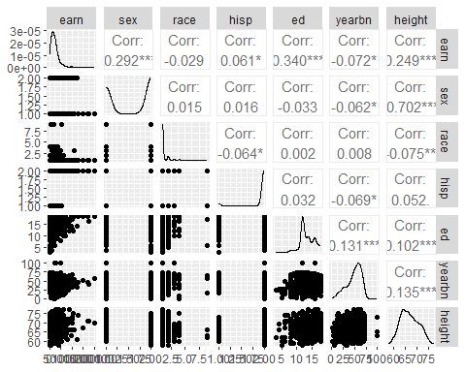

1. Make a summary of all variables:

summary(ht)

## earn sex race hisp   
## Min. : 200 Min. :1.000 Min. :1.000 Min. :1.000   
## 1st Qu.: 10000 1st Qu.:1.000 1st Qu.:1.000 1st Qu.:2.000   
## Median : 20000 Median :2.000 Median :1.000 Median :2.000   
## Mean : 23155 Mean :1.576 Mean :1.167 Mean :1.943   
## 3rd Qu.: 30000 3rd Qu.:2.000 3rd Qu.:1.000 3rd Qu.:2.000   
## Max. :200000 Max. :2.000 Max. :9.000 Max. :2.000   
## ed yearbn height   
## Min. : 3.0 Min. : 1.00 Min. :58.00   
## 1st Qu.:12.0 1st Qu.:39.75 1st Qu.:64.00   
## Median :13.0 Median :52.00 Median :66.00   
## Mean :13.5 Mean :48.87 Mean :66.92   
## 3rd Qu.:16.0 3rd Qu.:61.00 3rd Qu.:70.00   
## Max. :18.0 Max. :99.00 Max. :77.00

1. Which variables are categorical? How many categories do they have? Make tables for each category. Make sure those variables are treated as factors.

str(ht)

## 'data.frame': 1192 obs. of 7 variables:  
## $ earn : num 50000 60000 30000 50000 51000 9000 29000 32000 2000 27000 ...  
## $ sex : int 1 2 2 2 2 2 2 1 1 1 ...  
## $ race : int 1 1 1 3 1 1 1 1 1 1 ...  
## $ hisp : int 2 2 2 2 2 2 2 2 1 2 ...  
## $ ed : num 16 16 16 16 17 15 12 17 15 12 ...  
## $ yearbn: num 45 32 61 99 51 64 41 44 69 64 ...  
## $ height: num 74 66 64 63 63 64 62 73 72 72 ...

ht$sex<-as.factor(ht$sex)  
ht$race<-as.factor(ht$race)  
ht$hisp<-as.factor(ht$hisp)  
ht$ed<-as.factor(ht$ed)  
  
class(ht$sex)

## [1] "factor"

class(ht$race)

## [1] "factor"

class(ht$hisp)

## [1] "factor"

class(ht$ed)

## [1] "factor"

table(ht$sex)

##   
## 1 2   
## 505 687

table(ht$race)

##   
## 1 2 3 4 9   
## 1051 112 15 11 3

table(ht$hisp)

##   
## 1 2   
## 68 1124

table(ht$ed)

##   
## 3 4 5 6 7 8 9 10 11 12 13 14 15 16 17 18   
## 1 2 3 6 2 21 17 26 29 432 104 176 63 169 66 75

categorical variables are : sex,race,hisp,ed sex has 2 categories race has 5 categories hisp has 2 categories ed has 16 categories

str(ht)

## 'data.frame': 1192 obs. of 7 variables:  
## $ earn : num 50000 60000 30000 50000 51000 9000 29000 32000 2000 27000 ...  
## $ sex : Factor w/ 2 levels "1","2": 1 2 2 2 2 2 2 1 1 1 ...  
## $ race : Factor w/ 5 levels "1","2","3","4",..: 1 1 1 3 1 1 1 1 1 1 ...  
## $ hisp : Factor w/ 2 levels "1","2": 2 2 2 2 2 2 2 2 1 2 ...  
## $ ed : Factor w/ 16 levels "3","4","5","6",..: 14 14 14 14 15 13 10 15 13 10 ...  
## $ yearbn: num 45 32 61 99 51 64 41 44 69 64 ...  
## $ height: num 74 66 64 63 63 64 62 73 72 72 ...

Pay attention to variables that need to be treated as factors. Convert those variables to factor.

1. Plot only numerical variables using ggpairs

numerical_vars <- sapply(ht, is.numeric)  
numerical_data <- ht[, numerical_vars]  
ggpairs(numerical_data)

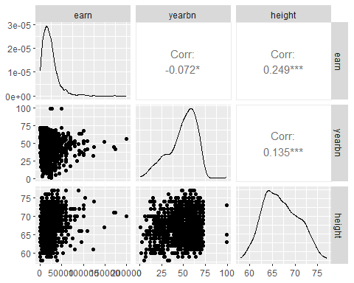

Note: If later on you decide to include the variable yearbn, that a minute to think about what it means and if you should do something to it before using it. The survey was done in 1990. Think about this: a person whose yearbn=0 was born in what year? a person whose yearbn=99 was born in what year?

* + 1. Fit a linear regression model predicting earnings from height and print the model summary.

htmod <- lm(earn ~ height, data=ht)  
summary(htmod)

##   
## Call:  
## lm(formula = earn ~ height, data = ht)  
##   
## Residuals:  
## Min 1Q Median 3Q Max   
## -30166 -11309 -3428 6527 172953   
##   
## Coefficients:  
## Estimate Std. Error t value Pr(>|t|)   
## (Intercept) -61316.3 9525.2 -6.437 1.76e-10 ***  
## height 1262.3 142.1 8.883 < 2e-16 ***  
## ---  
## Signif. codes: 0 '***' 0.001 '**' 0.01 '*' 0.05 '.' 0.1 ' ' 1  
##   
## Residual standard error: 18870 on 1190 degrees of freedom  
## Multiple R-squared: 0.06218, Adjusted R-squared: 0.06139   
## F-statistic: 78.9 on 1 and 1190 DF, p-value: < 2.2e-16

plot(htmod)

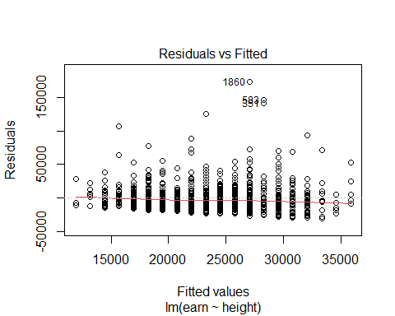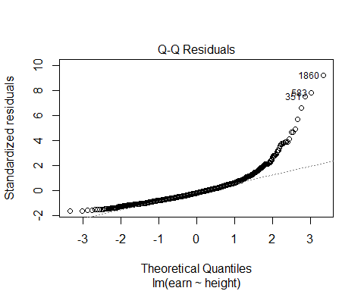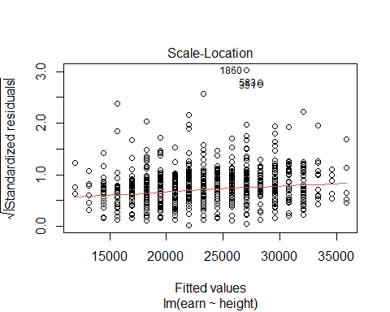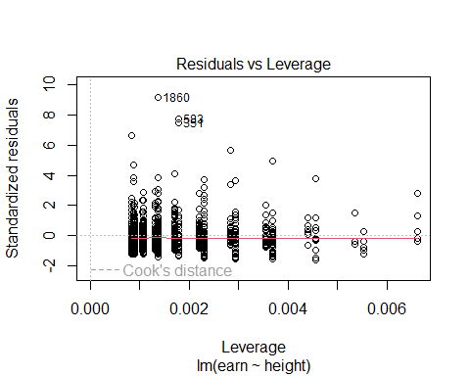

* + 1. What transformation should you perform in order to interpret the intercept from this model as average earnings for people with average height?

Transform the variable height and fit a new model of earn on the transformed variable. Print the summary of the model.

ht$newHeight <- ht$height-mean(ht$height)  
modHeightA <- lm(earn~newHeight,ht)  
summary(modHeightA)

##   
## Call:  
## lm(formula = earn ~ newHeight, data = ht)  
##   
## Residuals:  
## Min 1Q Median 3Q Max   
## -30166 -11309 -3428 6527 172953   
##   
## Coefficients:  
## Estimate Std. Error t value Pr(>|t|)   
## (Intercept) 23154.8 546.4 42.376 <2e-16 ***  
## newHeight 1262.3 142.1 8.883 <2e-16 ***  
## ---  
## Signif. codes: 0 '***' 0.001 '**' 0.01 '*' 0.05 '.' 0.1 ' ' 1  
##   
## Residual standard error: 18870 on 1190 degrees of freedom  
## Multiple R-squared: 0.06218, Adjusted R-squared: 0.06139   
## F-statistic: 78.9 on 1 and 1190 DF, p-value: < 2.2e-16

plot(modHeightA)

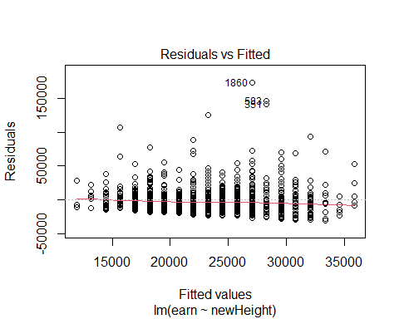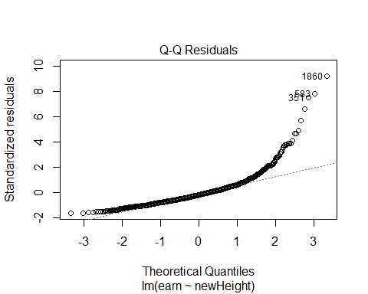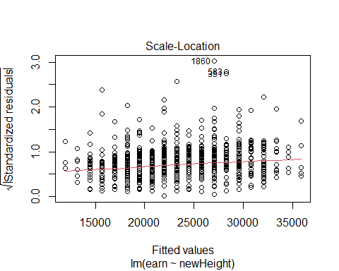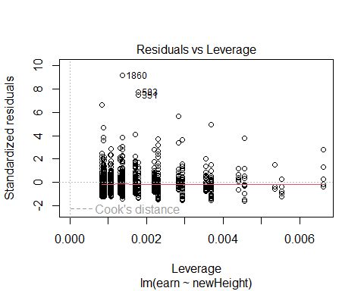

ggplot(ht,aes(x=newHeight,y=earn,col=sex))+geom_point()+  
geom_smooth(method = lm)

## `geom_smooth()` using formula = 'y ~ x'

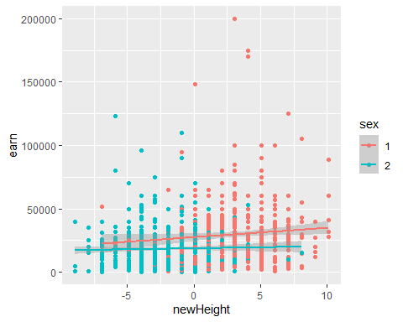

* + 1. Fit some regression models with the goal of predicting earnings from some combination of sex, height, race and education. Be sure to try various transformations and interactions that might make sense. Choose your preferred model and justify. Use ggplot() with color equal the categorical variable on which you are considering interactions to guide your analysis.

modHeightB<-lm(earn~sex*newHeight+race+hisp+ed,data=ht)  
summary(modHeightB)

##   
## Call:  
## lm(formula = earn ~ sex * newHeight + race + hisp + ed, data = ht)  
##   
## Residuals:  
## Min 1Q Median 3Q Max   
## -53308 -9734 -1991 5997 147423   
##   
## Coefficients:  
## Estimate Std. Error t value Pr(>|t|)   
## (Intercept) 9860.5 17255.6 0.571 0.5678   
## sex2 -9410.1 1451.0 -6.485 1.3e-10 ***  
## newHeight 576.7 265.0 2.176 0.0297 *   
## race2 -2720.3 1724.6 -1.577 0.1150   
## race3 1257.7 4580.0 0.275 0.7837   
## race4 -7745.4 5230.8 -1.481 0.1389   
## race9 7244.4 10412.1 0.696 0.4867   
## hisp2 4731.1 2201.7 2.149 0.0319 *   
## ed4 -3975.8 21191.5 -0.188 0.8512   
## ed5 -1710.5 19988.3 -0.086 0.9318   
## ed6 -2308.8 18739.9 -0.123 0.9020   
## ed7 -3451.5 21224.8 -0.163 0.8708   
## ed8 2553.5 17721.7 0.144 0.8855   
## ed9 4154.9 17825.7 0.233 0.8157   
## ed10 7873.5 17670.9 0.446 0.6560   
## ed11 10083.0 17623.5 0.572 0.5673   
## ed12 9000.0 17353.1 0.519 0.6041   
## ed13 12099.7 17409.7 0.695 0.4872   
## ed14 15021.2 17381.4 0.864 0.3877   
## ed15 11936.5 17458.0 0.684 0.4943   
## ed16 17614.8 17387.0 1.013 0.3112   
## ed17 19661.0 17468.8 1.125 0.2606   
## ed18 36207.6 17458.5 2.074 0.0383 *   
## sex2:newHeight -769.9 368.0 -2.092 0.0367 *   
## ---  
## Signif. codes: 0 '***' 0.001 '**' 0.01 '*' 0.05 '.' 0.1 ' ' 1  
##   
## Residual standard error: 17190 on 1168 degrees of freedom  
## Multiple R-squared: 0.2355, Adjusted R-squared: 0.2205   
## F-statistic: 15.65 on 23 and 1168 DF, p-value: < 2.2e-16

plot(modHeightB)

## Warning: not plotting observations with leverage one:  
## 1091

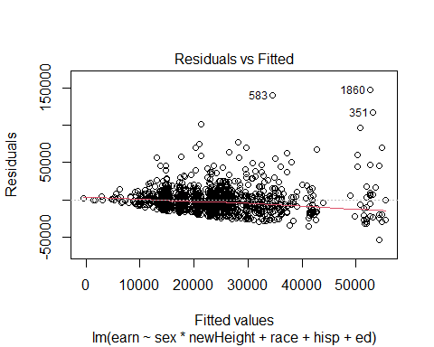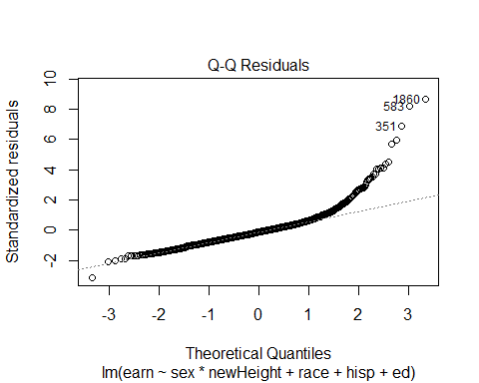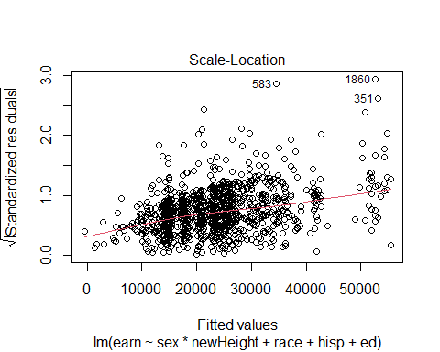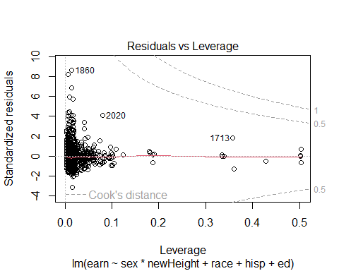

ggplot(ht,aes(x=newHeight,y=earn,col=sex))+geom_point()+geom_smooth(method = lm)

## `geom_smooth()` using formula = 'y ~ x'



modHeightC<-lm(earn~sex+race*newHeight+hisp+ed,data=ht)  
summary(modHeightC)

##   
## Call:  
## lm(formula = earn ~ sex + race * newHeight + hisp + ed, data = ht)  
##   
## Residuals:  
## Min 1Q Median 3Q Max   
## -52836 -9800 -2133 5900 147038   
##   
## Coefficients:  
## Estimate Std. Error t value Pr(>|t|)   
## (Intercept) 12585.93 17231.80 0.730 0.4653   
## sex2 -9754.18 1442.49 -6.762 2.15e-11 ***  
## race2 -3004.45 1730.38 -1.736 0.0828 .   
## race3 828.29 5848.98 0.142 0.8874   
## race4 -7647.26 5400.63 -1.416 0.1570   
## race9 -13176.22 21932.84 -0.601 0.5481   
## newHeight 291.19 194.06 1.501 0.1338   
## hisp2 4435.97 2217.26 2.001 0.0457 *   
## ed4 -5714.59 21191.90 -0.270 0.7875   
## ed5 -1978.70 20002.93 -0.099 0.9212   
## ed6 -3634.10 18823.11 -0.193 0.8469   
## ed7 -2119.30 21242.01 -0.100 0.9205   
## ed8 1397.92 17726.58 0.079 0.9372   
## ed9 3992.81 17832.47 0.224 0.8229   
## ed10 6254.51 17675.95 0.354 0.7235   
## ed11 9114.08 17626.57 0.517 0.6052   
## ed12 7749.54 17357.69 0.446 0.6553   
## ed13 10946.51 17411.81 0.629 0.5297   
## ed14 13694.98 17384.52 0.788 0.4310   
## ed15 10871.62 17463.62 0.623 0.5337   
## ed16 16363.26 17390.77 0.941 0.3469   
## ed17 18324.40 17474.16 1.049 0.2946   
## ed18 35042.56 17463.03 2.007 0.0450 *   
## race2:newHeight -992.44 438.05 -2.266 0.0237 *   
## race3:newHeight 55.69 1734.38 0.032 0.9744   
## race4:newHeight -261.71 1348.40 -0.194 0.8461   
## race9:newHeight -6367.03 6059.81 -1.051 0.2936   
## ---  
## Signif. codes: 0 '***' 0.001 '**' 0.01 '*' 0.05 '.' 0.1 ' ' 1  
##   
## Residual standard error: 17200 on 1165 degrees of freedom  
## Multiple R-squared: 0.2368, Adjusted R-squared: 0.2198   
## F-statistic: 13.9 on 26 and 1165 DF, p-value: < 2.2e-16

plot(modHeightC)

## Warning: not plotting observations with leverage one:  
## 1091

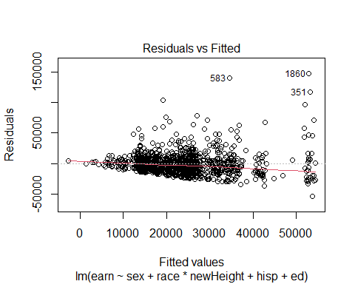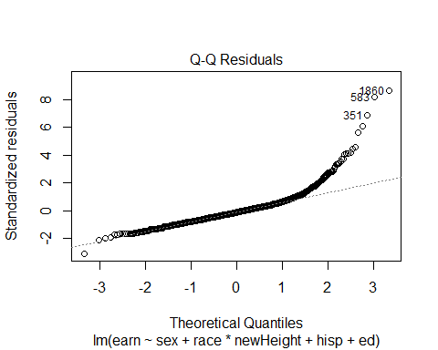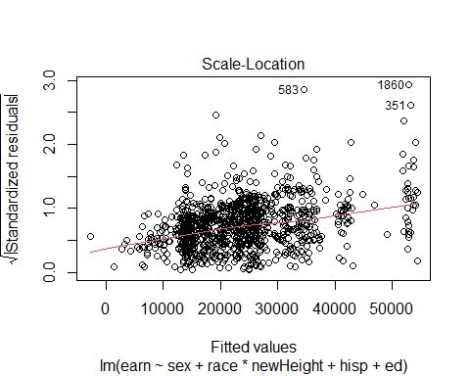

## Warning in sqrt(crit * p * (1 - hh)/hh): NaNs produced

## Warning in sqrt(crit * p * (1 - hh)/hh): NaNs produced

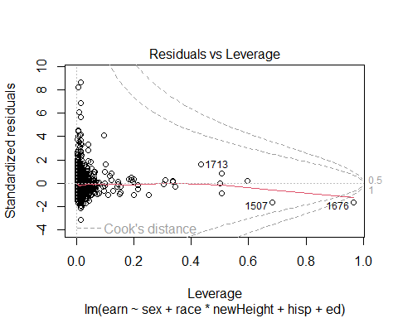

ggplot(ht,aes(x=newHeight,y=earn,col=race))+geom_point()+  
geom_smooth(method = lm)

## `geom_smooth()` using formula = 'y ~ x'

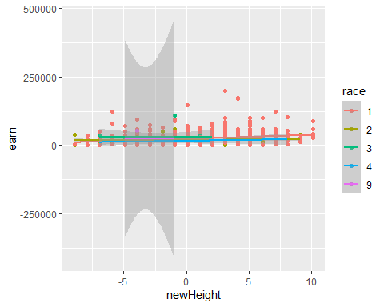

modHeightD<-lm(earn~sex+race+hisp*newHeight+ed,data=ht)  
summary(modHeightD)

##   
## Call:  
## lm(formula = earn ~ sex + race + hisp * newHeight + ed, data = ht)  
##   
## Residuals:  
## Min 1Q Median 3Q Max   
## -52374 -9988 -1916 6014 147266   
##   
## Coefficients:  
## Estimate Std. Error t value Pr(>|t|)   
## (Intercept) 9730.7 17449.4 0.558 0.5772   
## sex2 -9789.2 1442.1 -6.788 1.8e-11 ***  
## race2 -2716.9 1727.4 -1.573 0.1160   
## race3 608.1 4574.0 0.133 0.8943   
## race4 -7479.9 5237.8 -1.428 0.1535   
## race9 6663.9 10437.9 0.638 0.5233   
## hisp2 5065.1 2240.5 2.261 0.0240 *   
## newHeight -296.6 569.1 -0.521 0.6023   
## ed4 -3425.5 21328.9 -0.161 0.8724   
## ed5 1274.8 20166.7 0.063 0.9496   
## ed6 -697.7 18892.4 -0.037 0.9705   
## ed7 -1628.4 21355.5 -0.076 0.9392   
## ed8 3672.4 17884.8 0.205 0.8373   
## ed9 5417.6 17983.4 0.301 0.7633   
## ed10 8635.9 17822.8 0.485 0.6281   
## ed11 11072.4 17778.9 0.623 0.5335   
## ed12 10030.6 17512.1 0.573 0.5669   
## ed13 13169.3 17589.8 0.749 0.4542   
## ed14 16011.3 17547.8 0.912 0.3617   
## ed15 13253.9 17643.0 0.751 0.4527   
## ed16 18648.7 17550.4 1.063 0.2882   
## ed17 20529.2 17620.4 1.165 0.2442   
## ed18 37280.8 17621.0 2.116 0.0346 *   
## hisp2:newHeight 510.0 570.3 0.894 0.3714   
## ---  
## Signif. codes: 0 '***' 0.001 '**' 0.01 '*' 0.05 '.' 0.1 ' ' 1  
##   
## Residual standard error: 17220 on 1168 degrees of freedom  
## Multiple R-squared: 0.2332, Adjusted R-squared: 0.2181   
## F-statistic: 15.44 on 23 and 1168 DF, p-value: < 2.2e-16

plot(modHeightD)

## Warning: not plotting observations with leverage one:  
## 1091

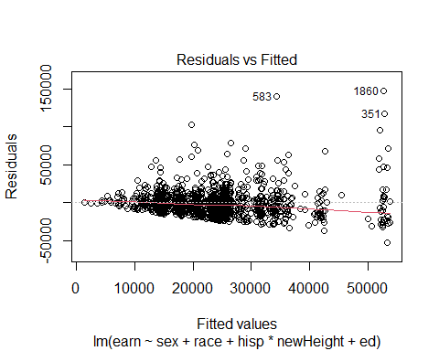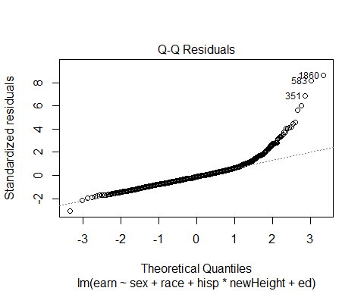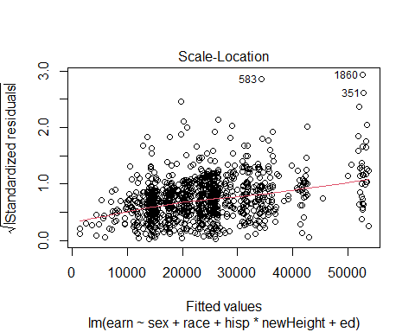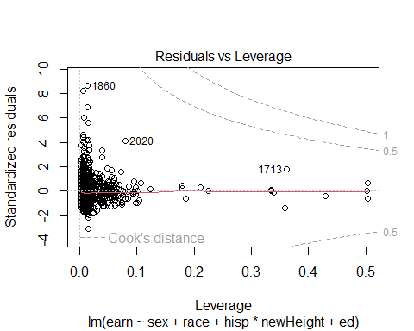

ggplot(ht,aes(x=newHeight,y=earn,col=hisp))+geom_point()+  
geom_smooth(method = lm)

## `geom_smooth()` using formula = 'y ~ x'

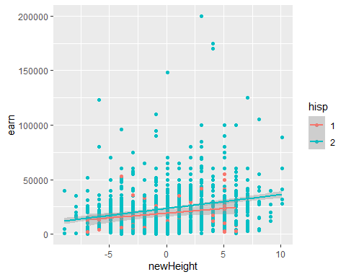

modHeightE<-lm(earn~sex+race+hisp+ed*newHeight,data=ht)  
sd(ht$ed18)

## [1] NA

sd(ht$newHeight)

## [1] 3.846638

summary(modHeightE)

##   
## Call:  
## lm(formula = earn ~ sex + race + hisp + ed * newHeight, data = ht)  
##   
## Residuals:  
## Min 1Q Median 3Q Max   
## -58086 -9707 -1973 5823 144861   
##   
## Coefficients: (1 not defined because of singularities)  
## Estimate Std. Error t value Pr(>|t|)   
## (Intercept) 17456.4 17423.1 1.002 0.3166   
## sex2 -9586.2 1447.0 -6.625 5.32e-11 ***  
## race2 -3031.2 1747.6 -1.734 0.0831 .   
## race3 1764.9 4604.6 0.383 0.7016   
## race4 -7521.9 5244.5 -1.434 0.1518   
## race9 7055.8 10876.6 0.649 0.5167   
## hisp2 4835.1 2223.5 2.175 0.0299 *   
## ed4 -11134.4 21871.5 -0.509 0.6108   
## ed5 -8259.7 46782.5 -0.177 0.8599   
## ed6 -8047.5 18957.8 -0.424 0.6713   
## ed7 20197.5 50221.2 0.402 0.6876   
## ed8 -4625.9 17965.1 -0.257 0.7968   
## ed9 -2238.7 18026.4 -0.124 0.9012   
## ed10 847.8 17873.8 0.047 0.9622   
## ed11 3446.3 17826.4 0.193 0.8467   
## ed12 2467.9 17558.0 0.141 0.8882   
## ed13 5885.7 17614.1 0.334 0.7383   
## ed14 8490.0 17583.0 0.483 0.6293   
## ed15 5085.4 17664.6 0.288 0.7735   
## ed16 10769.1 17590.2 0.612 0.5405   
## ed17 12893.1 17671.0 0.730 0.4658   
## ed18 28790.0 17729.5 1.624 0.1047   
## newHeight 1315.9 567.0 2.321 0.0205 *   
## ed4:newHeight -911.3 8134.0 -0.112 0.9108   
## ed5:newHeight -1383.1 6123.6 -0.226 0.8213   
## ed6:newHeight -1333.5 1569.9 -0.849 0.3958   
## ed7:newHeight -6326.3 8149.9 -0.776 0.4378   
## ed8:newHeight -1732.8 1107.4 -1.565 0.1179   
## ed9:newHeight -623.7 1136.7 -0.549 0.5833   
## ed10:newHeight -2459.2 1125.0 -2.186 0.0290 *   
## ed11:newHeight -1577.8 972.7 -1.622 0.1050   
## ed12:newHeight -1201.0 587.0 -2.046 0.0410 *   
## ed13:newHeight -414.5 715.6 -0.579 0.5626   
## ed14:newHeight -1597.1 642.9 -2.484 0.0131 *   
## ed15:newHeight -1926.5 771.2 -2.498 0.0126 *   
## ed16:newHeight -626.3 648.7 -0.966 0.3345   
## ed17:newHeight -983.1 799.9 -1.229 0.2193   
## ed18:newHeight NA NA NA NA   
## ---  
## Signif. codes: 0 '***' 0.001 '**' 0.01 '*' 0.05 '.' 0.1 ' ' 1  
##   
## Residual standard error: 17200 on 1155 degrees of freedom  
## Multiple R-squared: 0.2432, Adjusted R-squared: 0.2196   
## F-statistic: 10.31 on 36 and 1155 DF, p-value: < 2.2e-16

plot(modHeightE)

## Warning: not plotting observations with leverage one:  
## 702, 731, 958, 1060, 1091

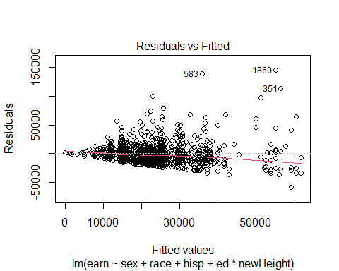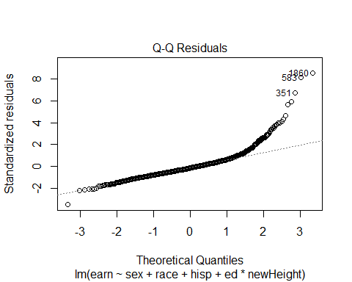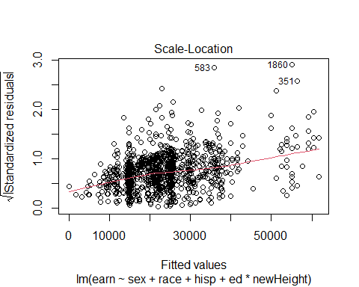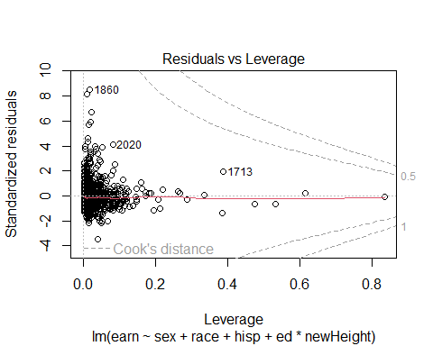

ggplot(ht,aes(x=newHeight,y=earn,col=ed))+geom_point()+  
geom_smooth(method = lm)

## `geom_smooth()` using formula = 'y ~ x'

## Warning in qt((1 - level)/2, df): NaNs produced

## Warning in qt((1 - level)/2, df): NaNs produced

## Warning in max(ids, na.rm = TRUE): no non-missing arguments to max; returning  
## -Inf  
  
## Warning in max(ids, na.rm = TRUE): no non-missing arguments to max; returning  
## -Inf

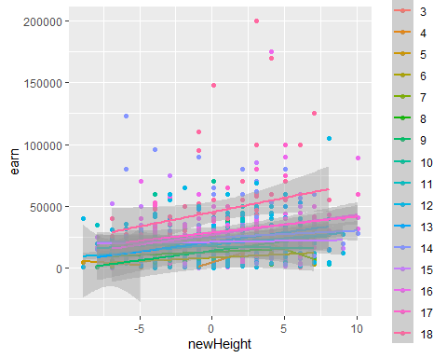

* + 1. Interpret all model coefficients.

from modHeightB: case sex1: earn=9860.5+576.7 newHeight case sex2: earn=9860.5+576.7 newHeight-9410.1-769.9 newHeight =450.4-193.2 newHeight case sex1:Increase in one unit of newHeight result in increase of 576.7 units of earnings. case sex2:Increase in one unit of newHeight result in decrease of 193.2 units of earnings.

from modHeightC:case race4: earn=12585.93-7647.26+291.19 newHeight-261.71 newHeight =4938.67+29.48 newHeight Increase in one unit of newHeight result in increase of 29.48 units of earnings.

from modHeightD:case hisp2: earn=9730.7+5065.1-296.6 newHeight+510.0 newHeight =14795.8+213.4 newHeight Increase in one unit of newHeight result in increase of 213.4 units of earnings.

from modHeightE:case ed9: earn=17456.4-2238.7+1315.9 newHeight-623.7 newHeight =15217.7+692.2 newHeight Increase in one unit of newHeight result in increase of 692.2 units of earnings.

In modHeightB:

For sex1, earnings increase by 576.7 units for each one-unit increase in newHeight. For sex2, earnings decrease by 193.2 units for each one-unit increase in newHeight. In modHeightC:

For race4, each one-unit increase in newHeight leads to a 29.48 unit increase in earnings. In modHeightD:

For hisp2, an increase of one unit in newHeight results in an earnings increase of 213.4 units. In modHeightE:

For ed9, earnings increase by 692.2 units for every one-unit increase in newHeight.

ed18:newHeight = 28790.0 + 1.624 * newHeight

So, the equation for “ed18” would be:

ed18 = 28790.0 + 1.624 * newHeight

* + 1. Examine the outliers and points of influence in your model with influencePlot()

library(car)

## Loading required package: carData

##   
## Attaching package: 'car'

## The following object is masked from 'package:dplyr':  
##   
## recode

influencePlot(modHeightE, id.method = "identify", main = "Influence Plot")

## Warning in plot.window(...): "id.method" is not a graphical parameter

## Warning in plot.xy(xy, type, ...): "id.method" is not a graphical parameter

## Warning in axis(side = side, at = at, labels = labels, ...): "id.method" is not  
## a graphical parameter  
  
## Warning in axis(side = side, at = at, labels = labels, ...): "id.method" is not  
## a graphical parameter

## Warning in box(...): "id.method" is not a graphical parameter

## Warning in title(...): "id.method" is not a graphical parameter

## Warning in plot.xy(xy.coords(x, y), type = type, ...): "id.method" is not a  
## graphical parameter

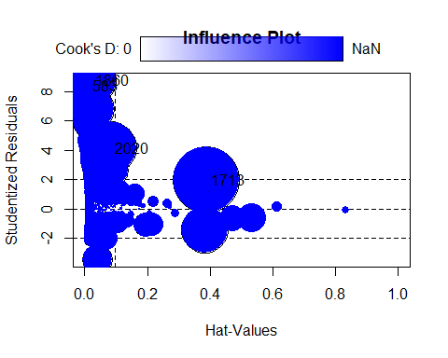

## StudRes Hat CookD  
## 583 8.375121 0.01164069 0.02106659  
## 1190 NaN 1.00000000 NaN  
## 1238 NaN 1.00000000 NaN  
## 1713 1.971823 0.38881370 0.06668336  
## 1860 8.778795 0.01920144 0.03825800  
## 2020 4.151855 0.08218496 0.04113927

Write a sentence about your findings.

The data points at 583, 1713, 1860, and 2020 exhibit a significant Cook’s distance, indicating their strong influence on the model. This influence, in turn, affects the estimation of the model’s coefficients. Therefore, it is advisable to conduct further analysis on these specific data points to improve the accuracy of the coefficient estimates.